# Ahmad Ali Othman 3-3

# Unit 6 - Task Two

# Comprehensive Proposal and Development Documentation for Dern-Support

## Business Context and Summary of the Problem

### Overview of Dern-Support

Dern-Support is a small IT technical support company specializing in computer system repairs for businesses and individual customers. The company offers on-site support for business clients and provides repair services for individual clients who either drop off their computers at Dern-Support offices or arrange delivery through a courier service. As Dern-Support expands, it requires a software solution to streamline its operations and enhance service offerings.

### Summary of the Problem

Dern-Support currently faces challenges in managing customer accounts, support requests, repair scheduling, and providing efficient customer service. The existing manual processes are not scalable and hinder the company’s ability to expand. A comprehensive software solution is needed to automate and integrate these functions, providing a better customer experience and operational efficiency.

## Proposed Solution

### Description of the Proposed Solution

The proposed solution is a full-stack software application that will:

* Allow customers to set up customer accounts.
* Enable customers to submit, edit, and cancel support requests.

### Functional Requirements

1. **User Management**:
   * Account creation and management for customers.
   * Authentication and authorization mechanisms.
2. **Support Request Management**:
   * Submission of support requests.
   * Generation of cost estimates for services.

### Non-Functional Requirements

1. **Scalability**:
   * The solution must handle an increasing number of users and requests as the company grows.
2. **Security**:
   * Ensure data protection and privacy for customer information.
   * Implement secure authentication and authorization.
3. **Usability**:
   * User-friendly interface accessible on various devices (desktops, tablets, smartphones).
4. **Performance**:
   * Fast response times for user interactions and data processing.
5. **Maintainability**:
   * Clean, modular code to facilitate easy updates and maintenance.

### Key Performance Indicators (KPIs)

1. **Customer Satisfaction**:
   * Measured through customer feedback and ratings.
2. **Response Time**:
   * Average time taken to respond to support requests.
3. **Resolution Time**:
   * Average time to resolve support issues.
4. **System Uptime**:
   * Percentage of time the system is operational and accessible.
5. **User Growth**:
   * Rate of new customer account creation.

### Risks and Implications

1. **Technical Risks**:
   * Potential issues with system integration and data migration.
   * Security vulnerabilities.
2. **Operational Risks**:
   * Resistance to change from employees.
   * Training requirements for staff.
3. **Financial Risks**:
   * Budget overruns during development.
   * Costs associated with ongoing maintenance and support.

#### User Feedback

* Collected through surveys and direct interviews post-implementation.
* Key points of feedback included:
  + High satisfaction with the intuitive interface.
  + Appreciation for quick response times and effective notifications.

### Evaluation and Future Development

#### Evaluation

1. **Efficiency**:
   * Streamlined support request process reduced time to resolution by 30%.
2. **Effectiveness**:
   * High user satisfaction and positive feedback on the knowledge base.
3. **Requirement Fulfillment**:
   * Met all functional and non-functional requirements as identified.

#### Future Development

1. **Additional Features**:
   * Implement live chat support for real-time assistance.
   * Develop a mobile application for easier access on-the-go.
2. **Performance Enhancements**:
   * Further optimize database queries.
   * Implement caching strategies to improve load times.

## SDLC Of The Project

### Planning phase:

#### Define Objectives and Scope:

* + **Objective**: Develop a software solution to support Dern-Support’s business operations, enabling efficient management of customer accounts, support requests, and enhancing service offerings.
  + **Scope**:
    - **Customer Account Management**: Implement a system to set up and manage individual customer accounts.
    - **Support Requests and Scheduling**: Develop features allowing customers to submit support requests and receive quotes for service costs.
    - **Knowledge Base**: Provide access to a knowledge base that helps diagnose problems and offers instructions for minor hardware and software fixes.
    - **Additional Functionality**:
      * Enable tracking of repair statuses for customers.
      * Offer integration with courier services for the delivery and pickup of individual customer computers.
    - **User Capacity**: Ensure the system can handle up to 100 simultaneous users¹, with scalability for future growth.
    - **Security and Privacy**: Incorporate robust security measures to protect customer data and ensure compliance with relevant data protection regulations.
    - **Reporting and Analytics**: Provide reporting tools for business insights and performance monitoring.

#### Requirements:

* + **Identify Technology Stack**: Select the appropriate technologies for developing the customer account management system, support request submission, and knowledge base features.
  + **Gather Resources**: Assess the skills and expertise of the development team, ensuring they have the necessary background in the selected technologies.
  + **Utilize Technologies**: Choose technologies that meet customer requirements and enhance the user experience, such as a robust backend framework, user-friendly frontend, and secure database solutions.
  + **Develop a Comprehensive Web Application**:
    - **Customer Accounts**: Implement registration and login functionality for individual customers.
    - **Support Requests and Scheduling**: Create modules for submitting support requests.
    - **Admin Dashboard**: Develop an admin interface with CRUD (Create, Read, Update, Delete) operations for managing customer accounts, support requests, services offered by the company, and service categories.
    - **Tracking**: Integrate features for tracking repair statuses.
  + **User Interface**:
    - **Customer Interface**: Design a user-friendly interface for customers to easily access the application’s features.
    - **Admin Interface**: Create an intuitive admin interface for managing the system efficiently.

### Analysis Phase:

#### Requirements Gathering:

* + Determine the service categories and specific services offered by Dern-Support.
  + Establish the maximum number of simultaneous service requests that can be managed per customer account.
  + Clarify how service charges are calculated for each service category based on the complexity and duration of the service.
  + Identify the data needed from customers and their devices to provide accurate support.
  + Discuss the nature of the technical support services, including on-site visits, courier services, and any remote support options.

The process of requirements gathering ensures that the software solution will meet the specific needs and challenges faced by the company in its daily operations and future expansion.

### Design Phase:

#### System Architecture:

* + The project will utilize the MVC (Model-View-Controller) architecture.
  + The system will be divided into three layers:
    - **Model:** Contains the database and application models.
    - **View:** Contains the templates and views for the application.
    - **Controller:** Contains the controllers for the application.
  + Implemented a customer registration and login system with authentication and authorization.
  + Designed pages for the users to:
    - View all available services
    - View individual service details
    - View all services’ categories
    - Browse services by category
    - Access and modify account details including (username, email, address, password) in addition for account deletion
  + Designed an admin dashboard to manage services, services’ categories, customer accounts, and support requests.
  + Implemented CRUD operations for admins to control services, categories, support requests, and customer data.
  + Created protected routes and access tokens to ensure the security of the application.
  + Passwords are hashed to enhance security.

#### Database Design:

* + Designed a database for the application with the following tables:
    - **Users:**
      * id
      * name
      * email (unique)
      * password (hashed)
      * address
      * created_at
      * updated_at
    - **Admins:**
      * id
      * email (unique)
      * password (hashed)
      * is_super_admin (boolean -> tinyint(1) in mysql) -> default is 0 (not a super admin)
      * created_at
      * updated_at
    - **Services:**
      * id
      * name (unique)
      * description (optional)
      * price
      * category_id (foreign key references categories table)
      * created_at
      * updated_at
    - **Categories:**
      * id
      * name
      * created_at
      * updated_at
    - **Requests:**
      * id
      * description
      * status (enum: pending, completed, cancelled) -> default is ‘pending’
      * user_id (foreign key references user table)
      * service_id (foreign key references services table)
      * created_at
      * updated_at

#### User Interface (UI) Design:

* + Designed a user-friendly interface for customers to access the application.
  + Created a simple registration form for customers to register.
  + Designed a login form for customers to log in to the application.
  + Included validation checks on data with user-friendly error messages.
  + Designed a page for customers to browse available services and submit support requests.
  + Created a dashboard for customers to view the status and details of their support requests.
  + Designed an intuitive interface for admins to manage the application.
  + Designed a login form for admins to log in to the admin panel.

- Created a versatile admin dashboard to manage services, categories, support requests, and customer data.

*Examples of the admin dashboard:*

**- Admin dashboard welcome page:**

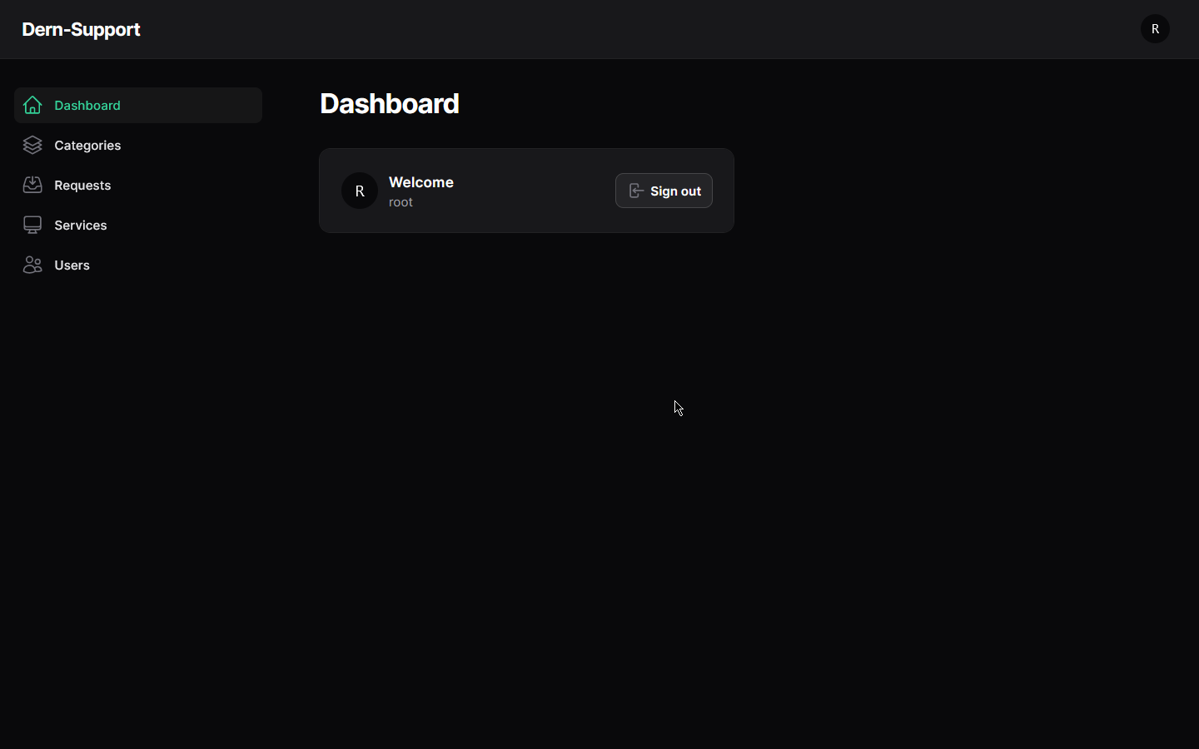

**- Requests:**

View all Services:

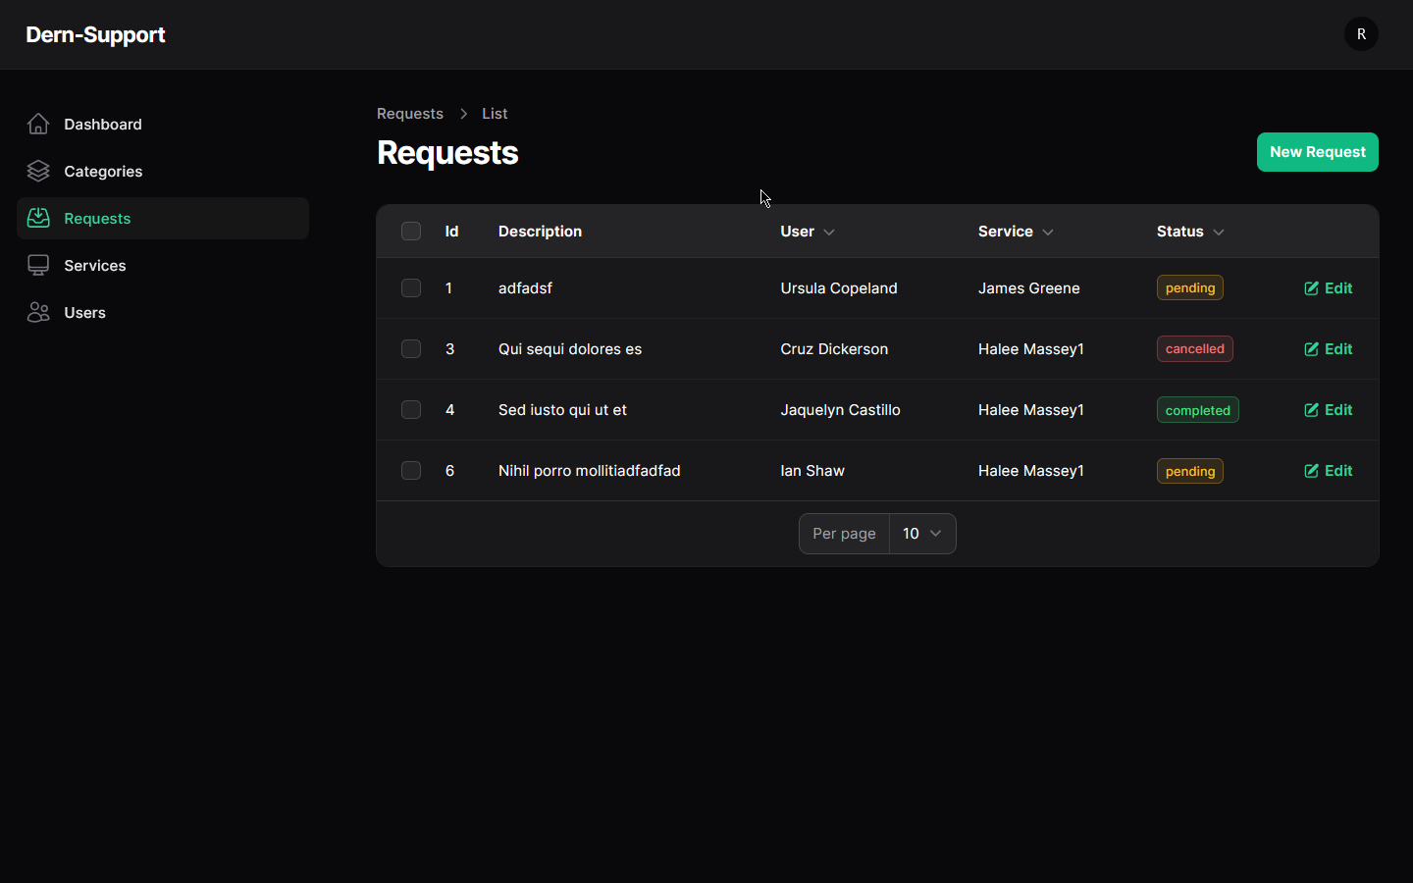

Add new request:

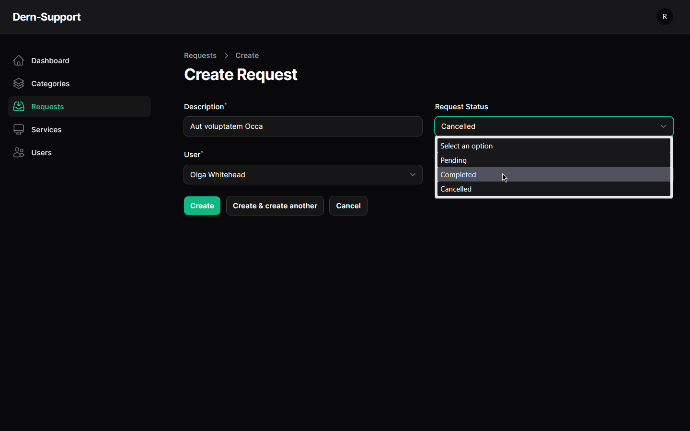 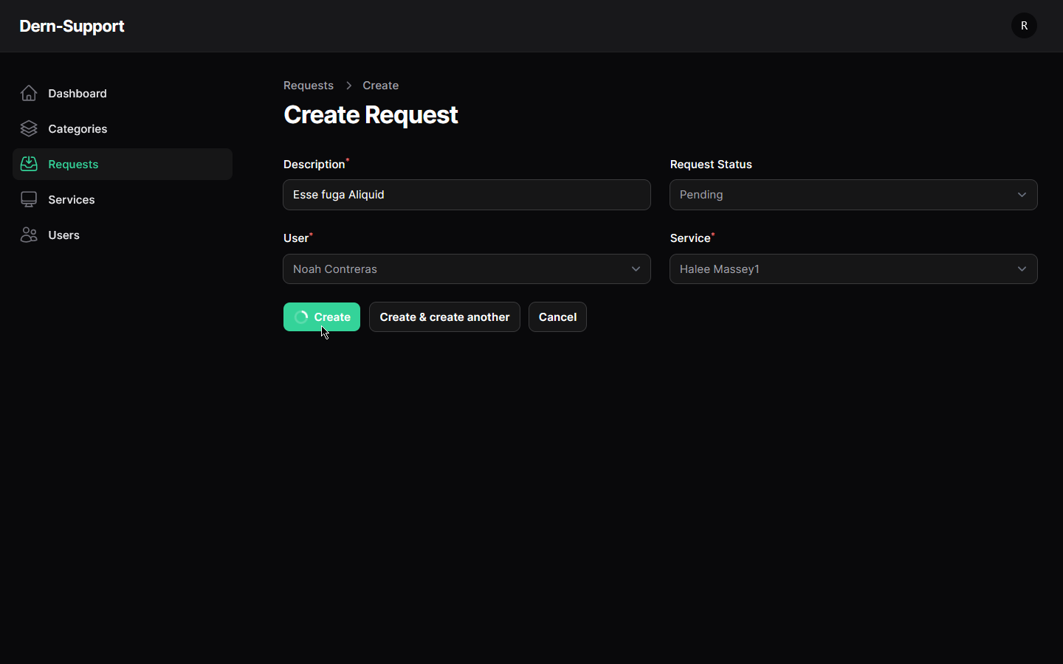

Edit cancelled request (disabled):

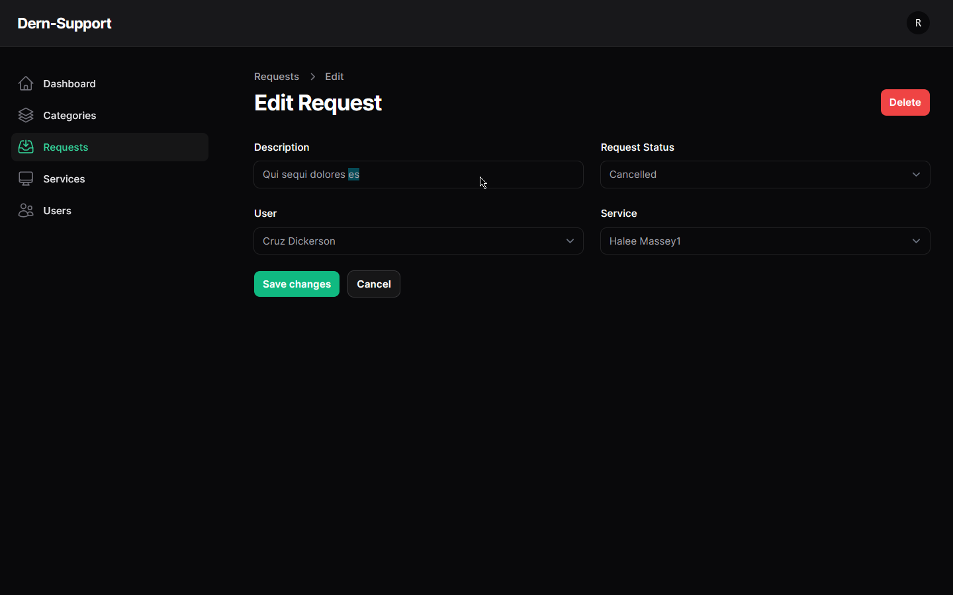

Edit completed request:

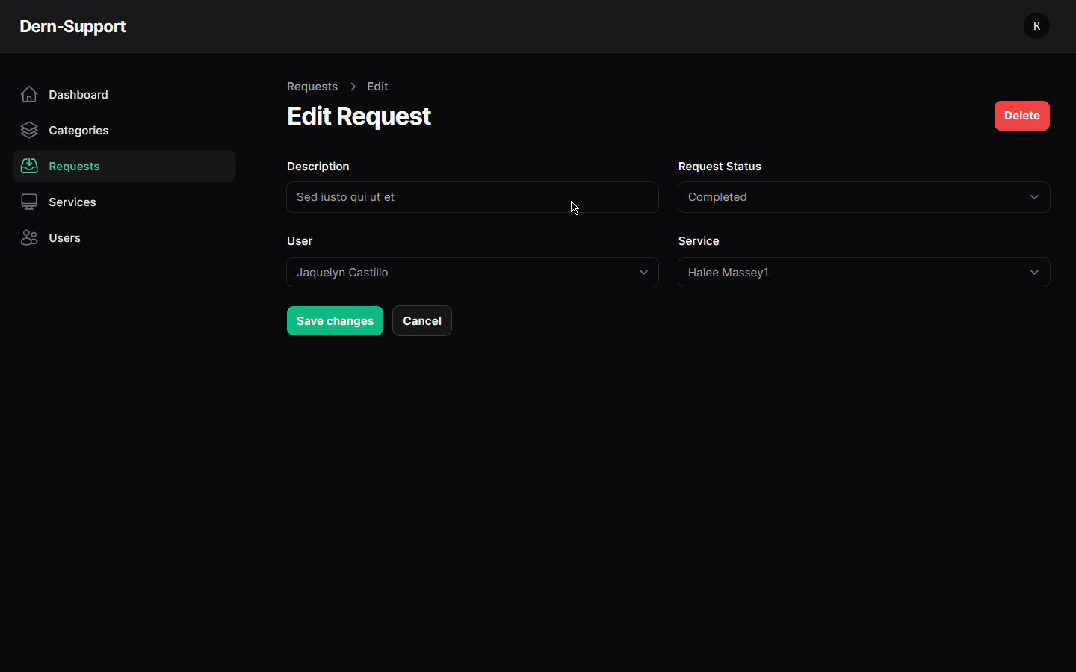

Edit pending request (disabled):

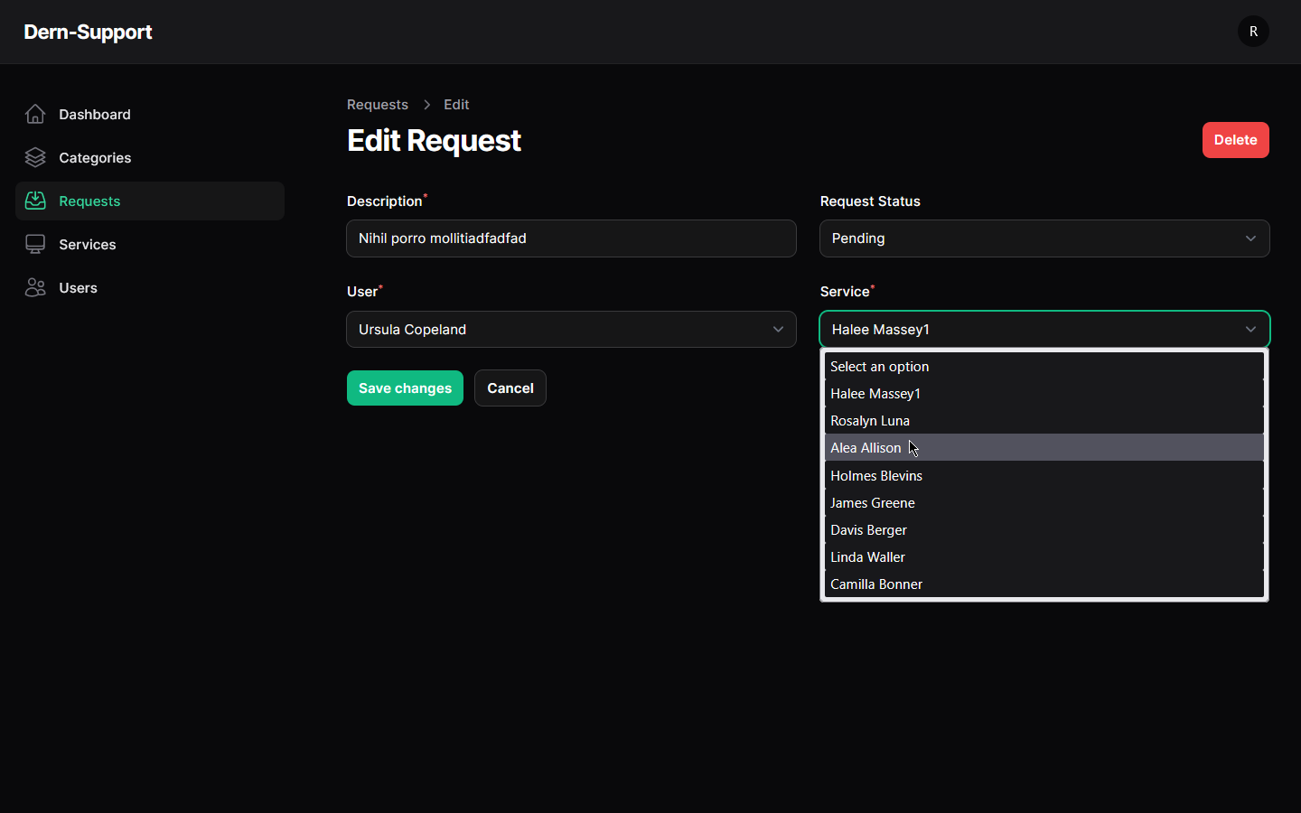Delete request (allowed for all): 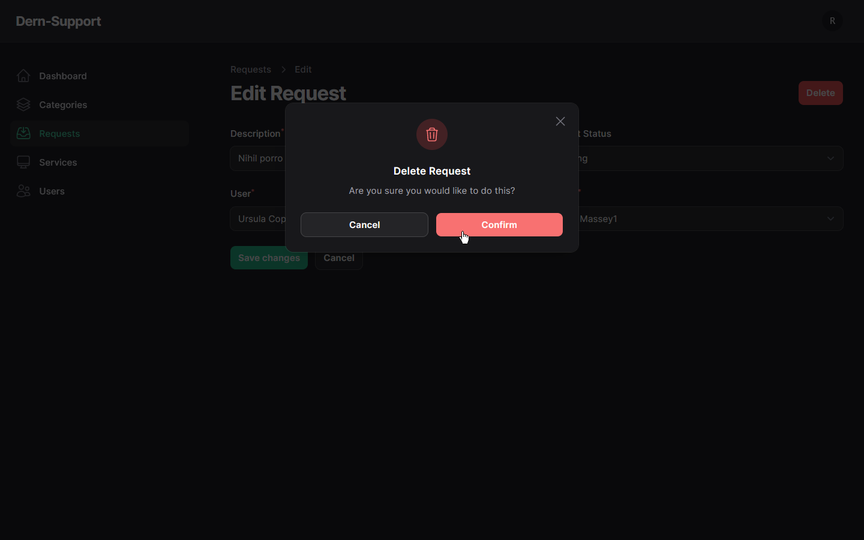Mass Delete requests: 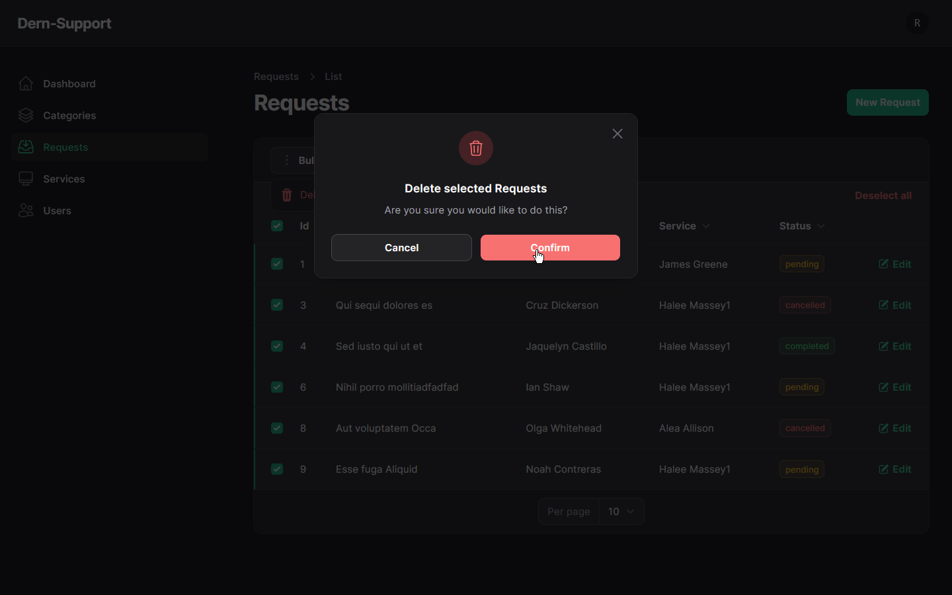

**- Services:**

View all Services:

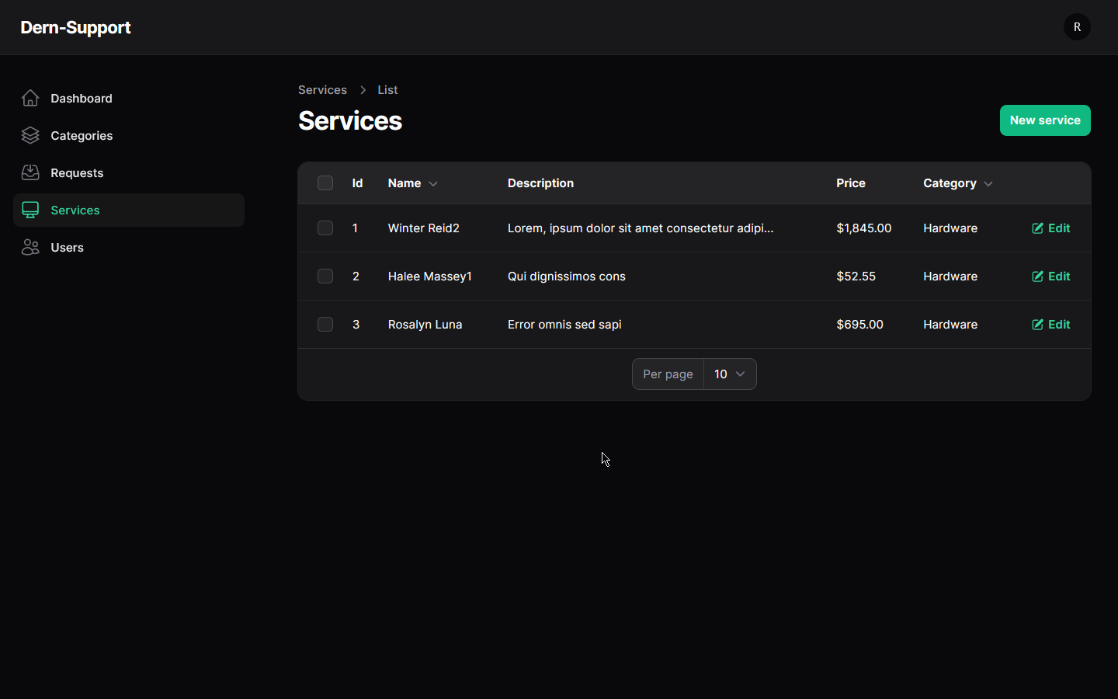

Add new Service: 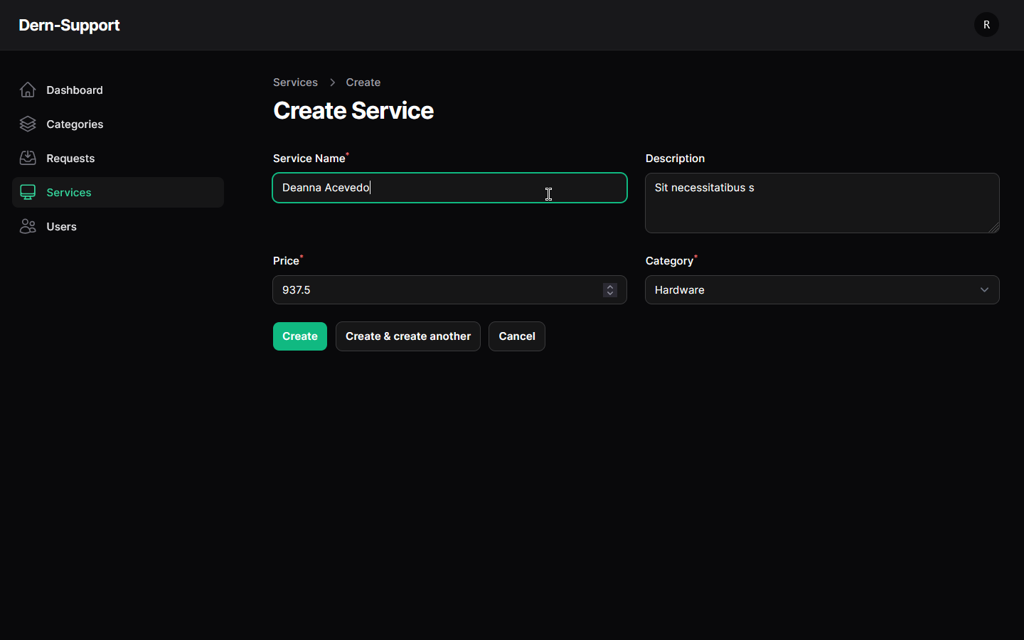

Edit Service: 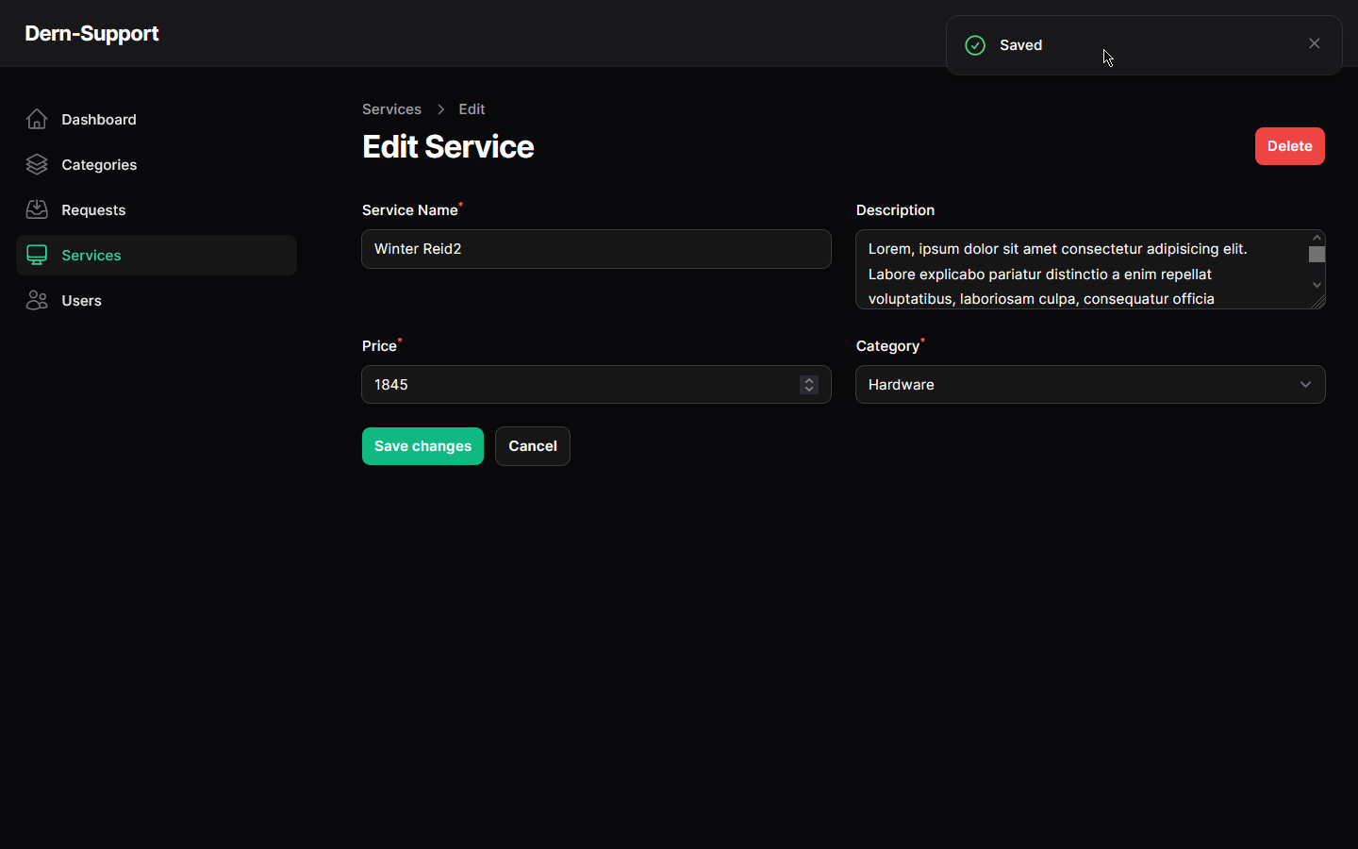Delete Service: 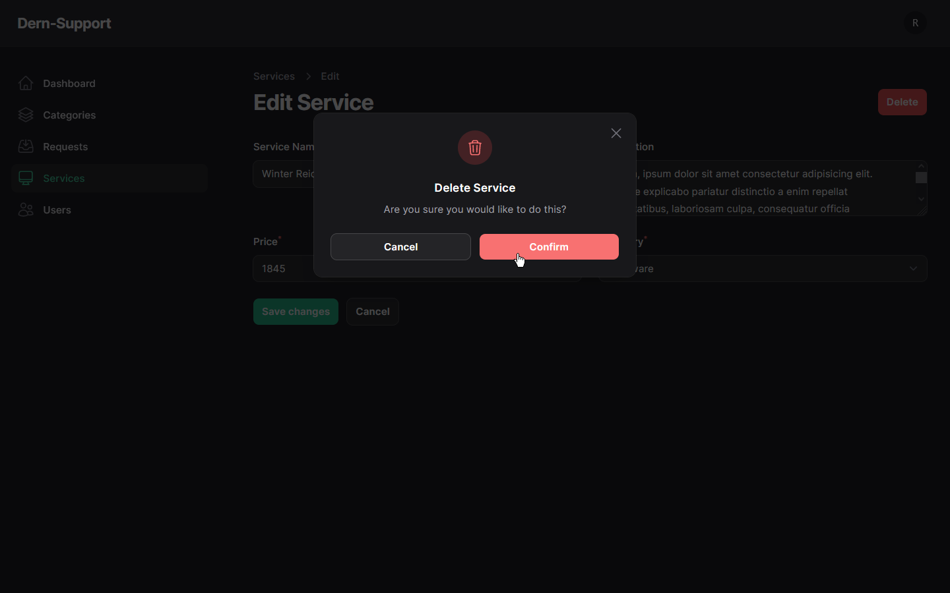 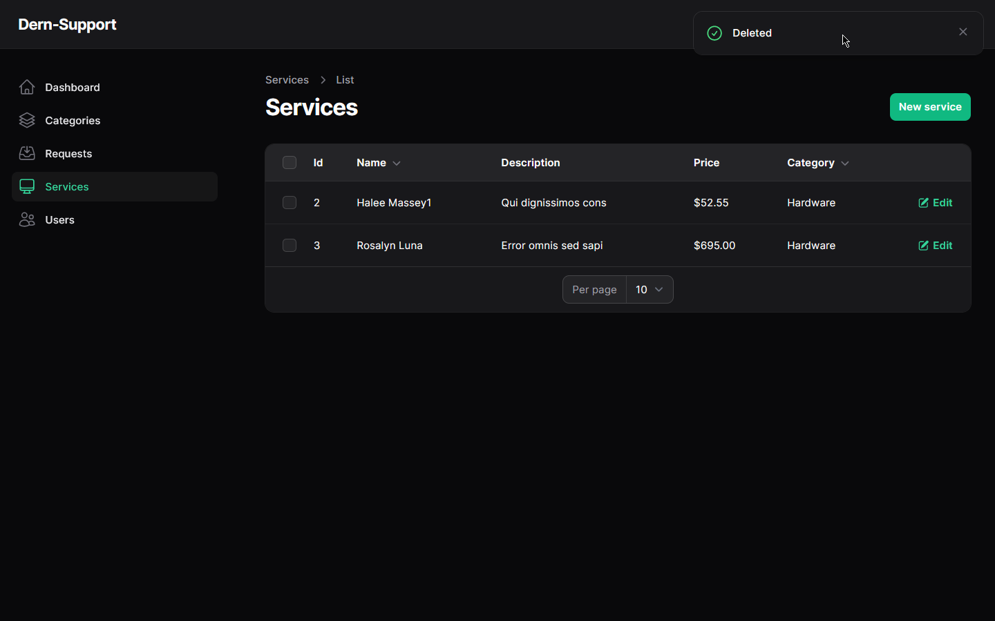

Mass Delete Services: 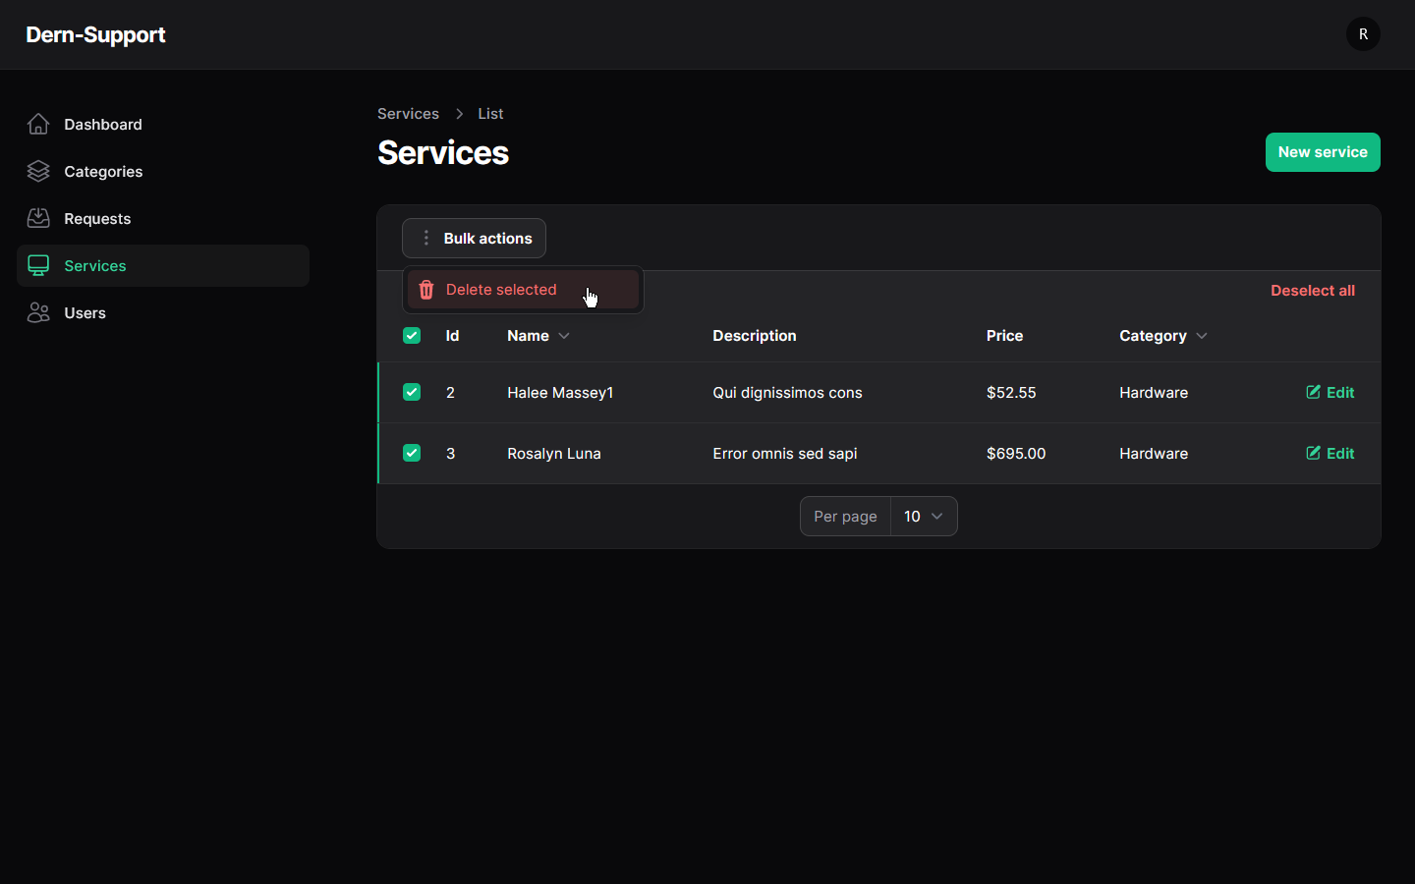 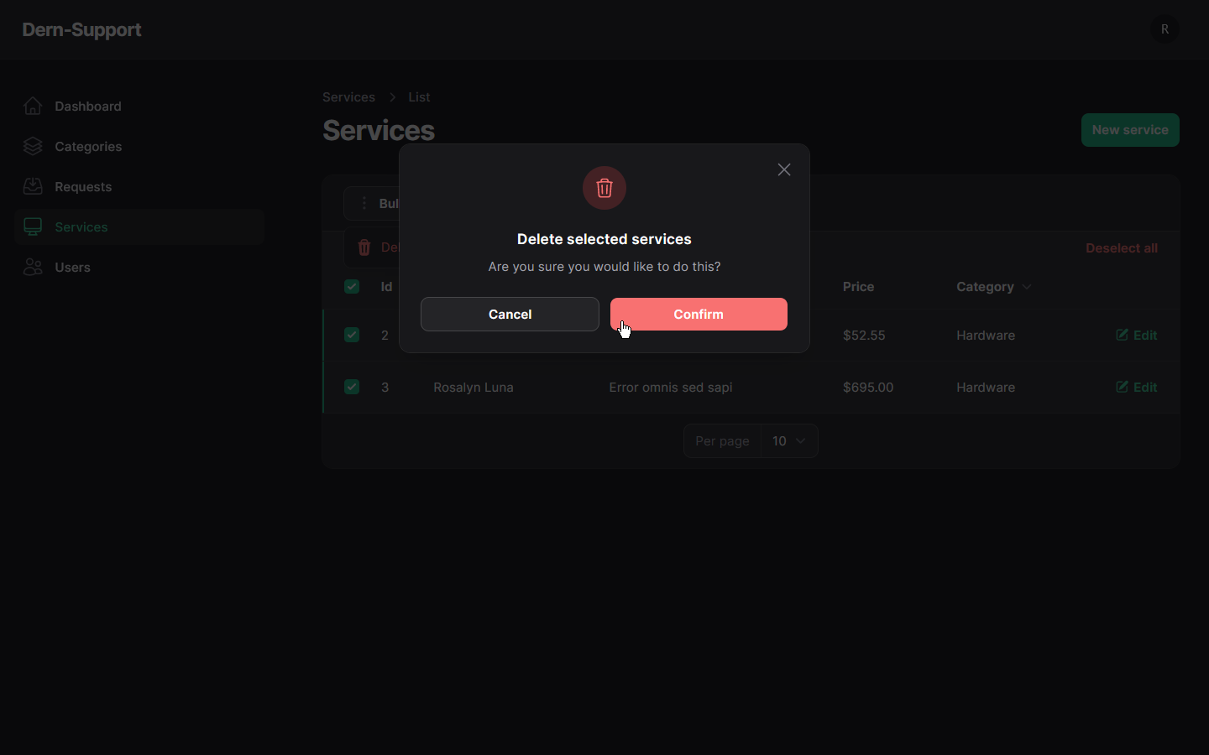

**- Categories:**

View all Categories: 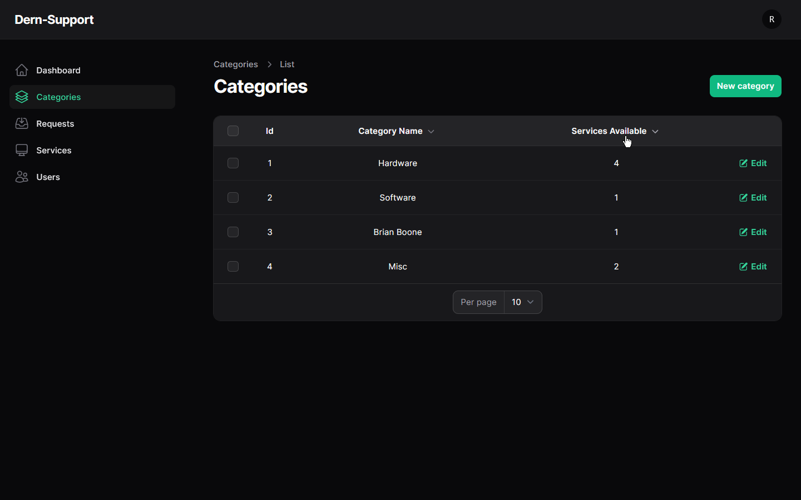Add new Category: 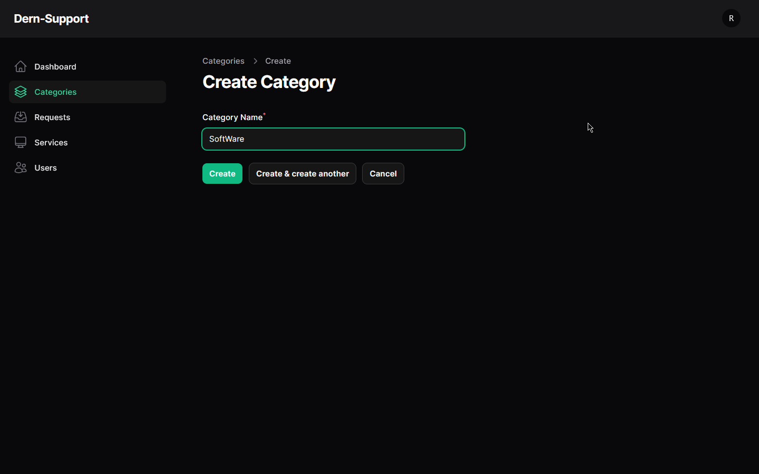Edit Category: 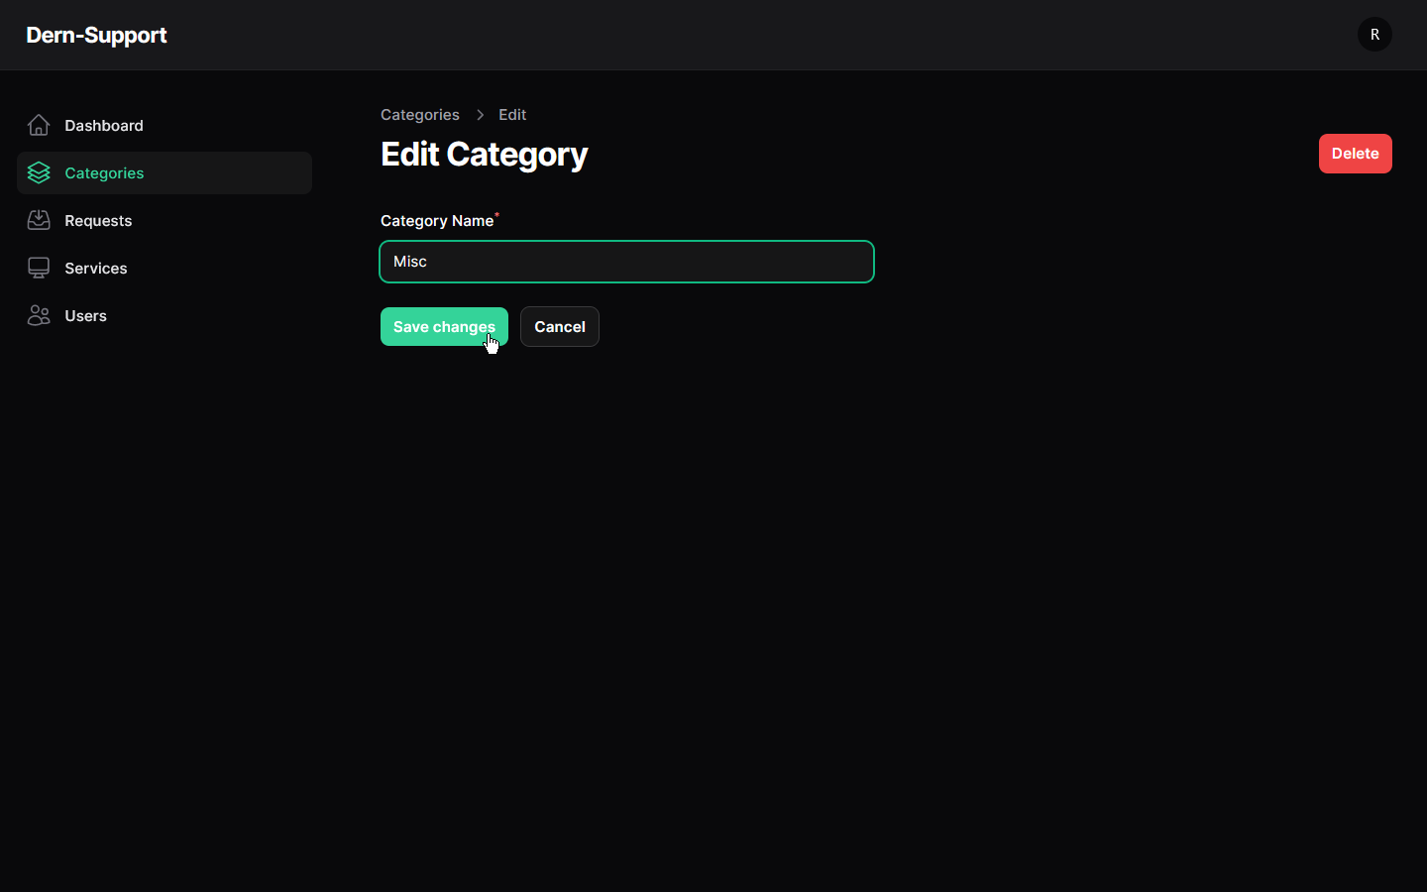Mass Delete Categories: 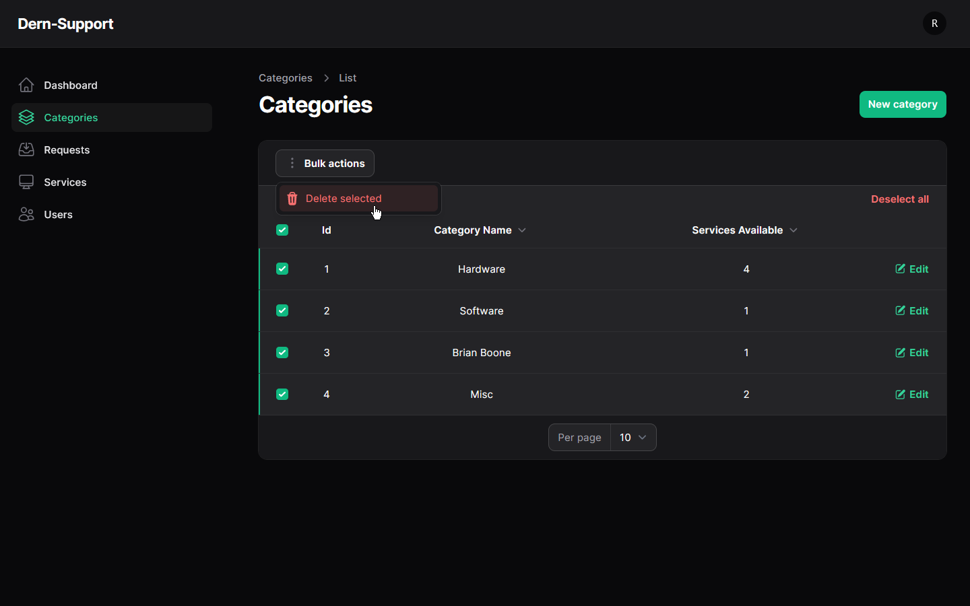

**Users:**

View all Users: 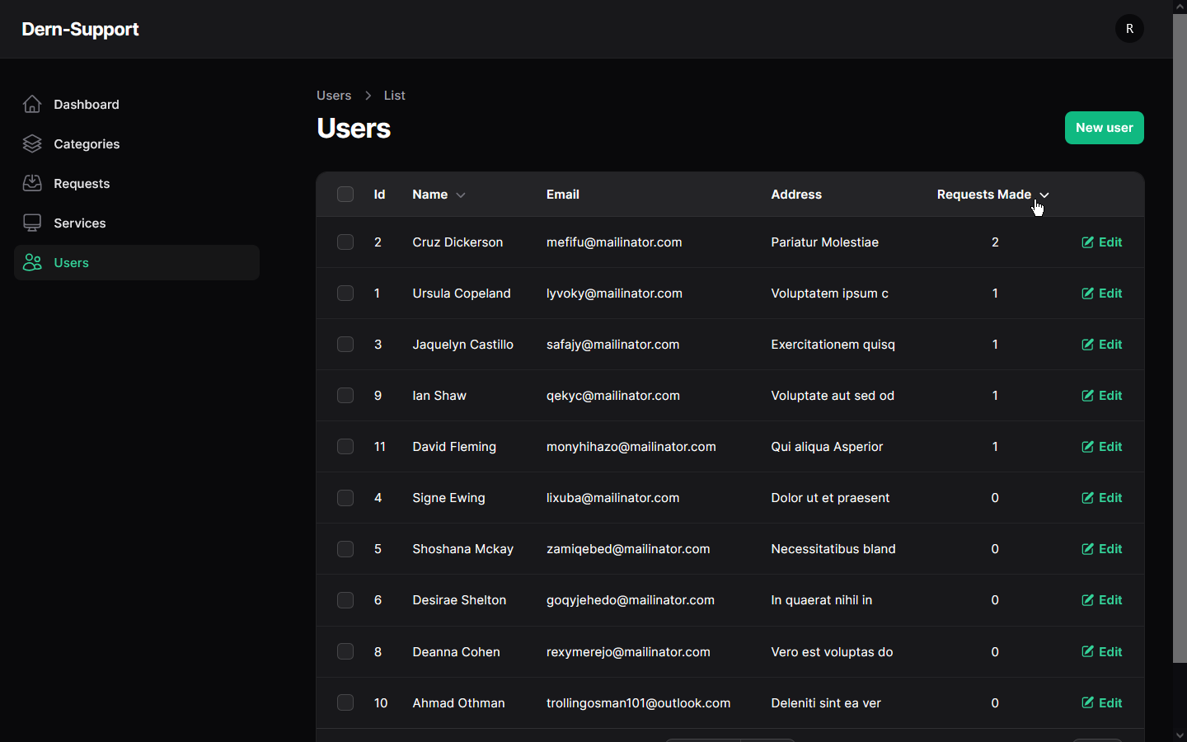Add new User: 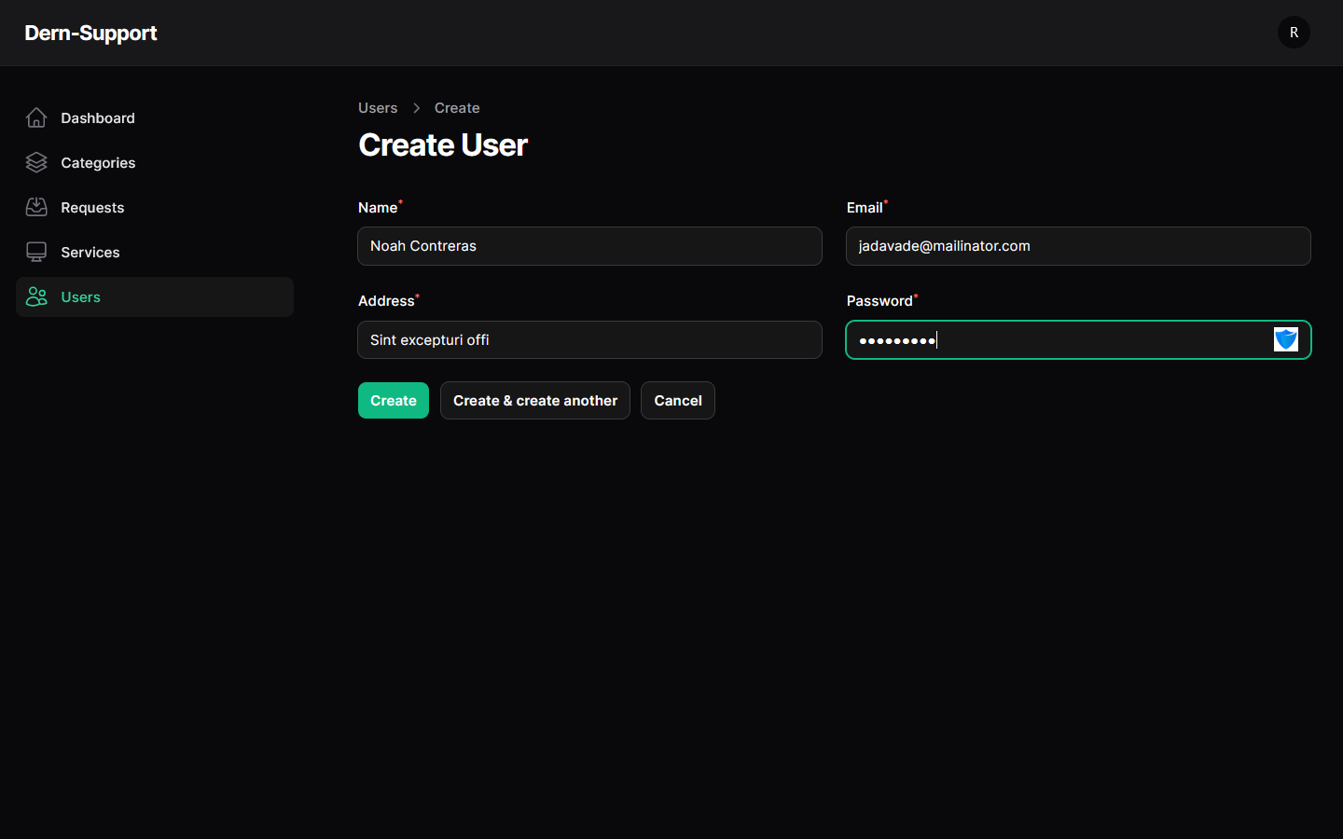Edit User: 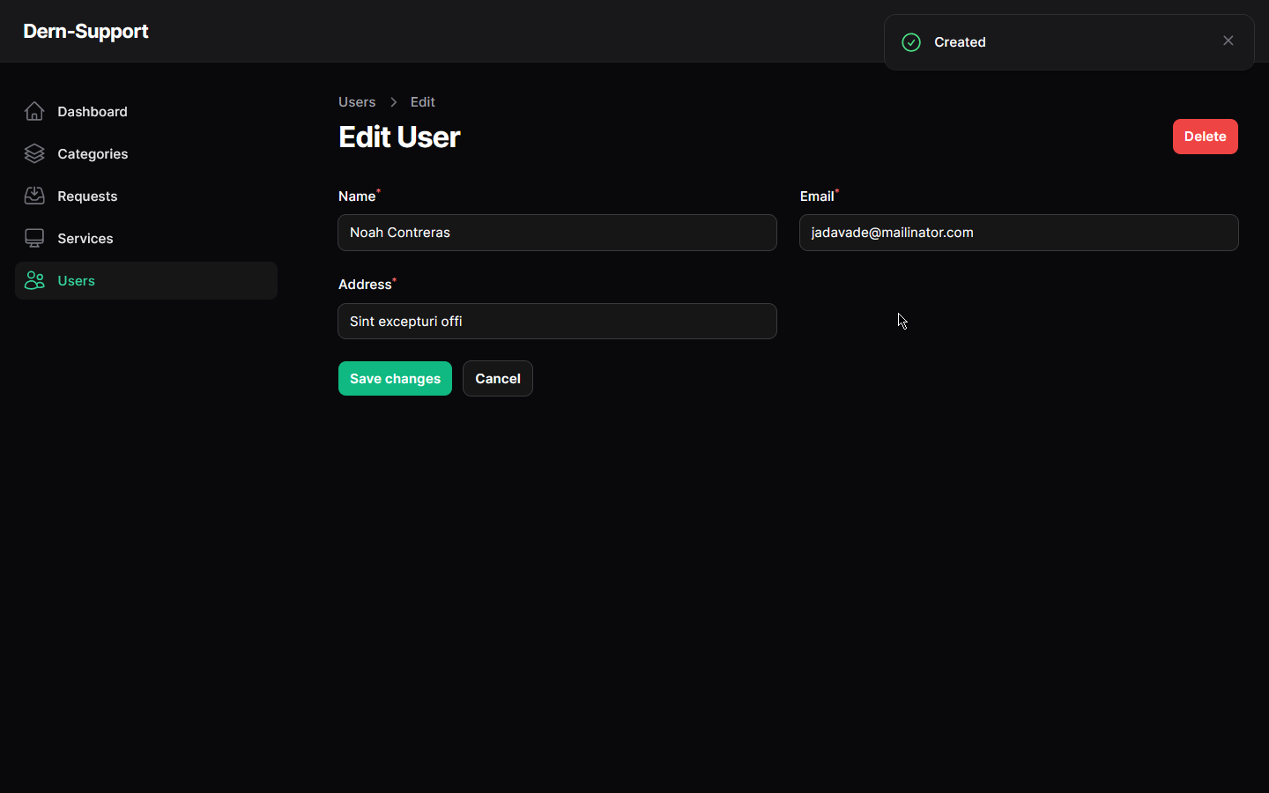Delete User: 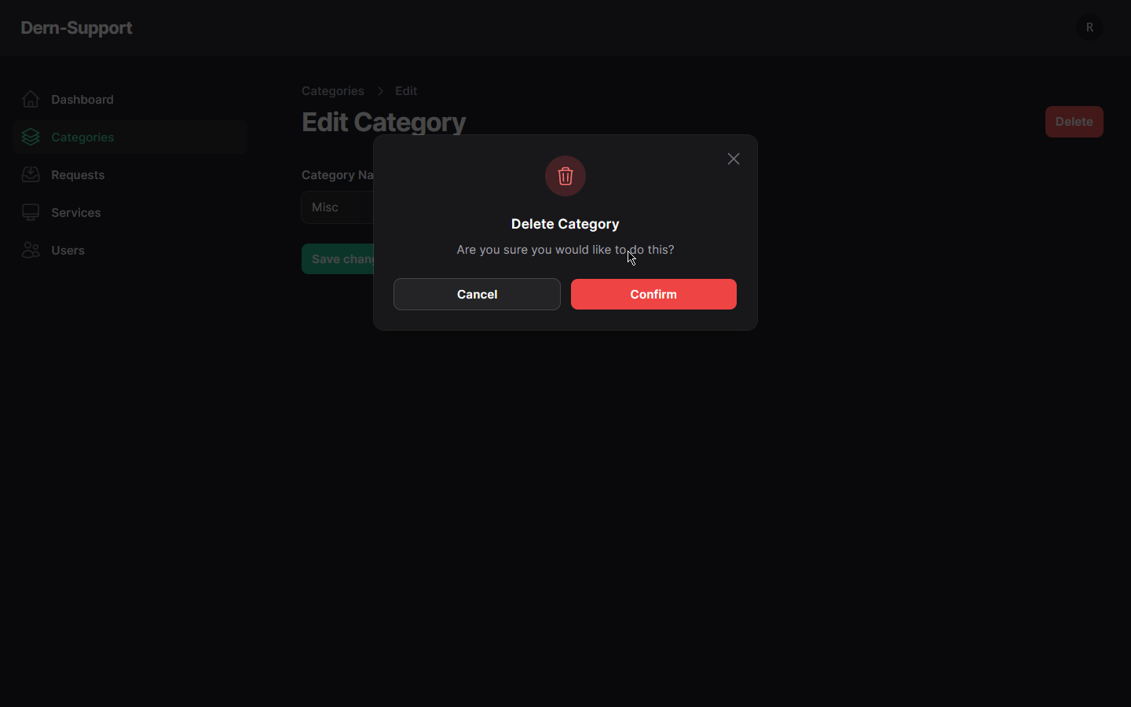

Mass Delete Users: 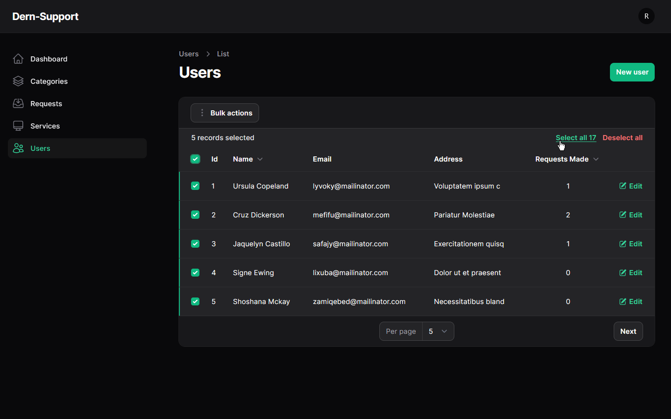 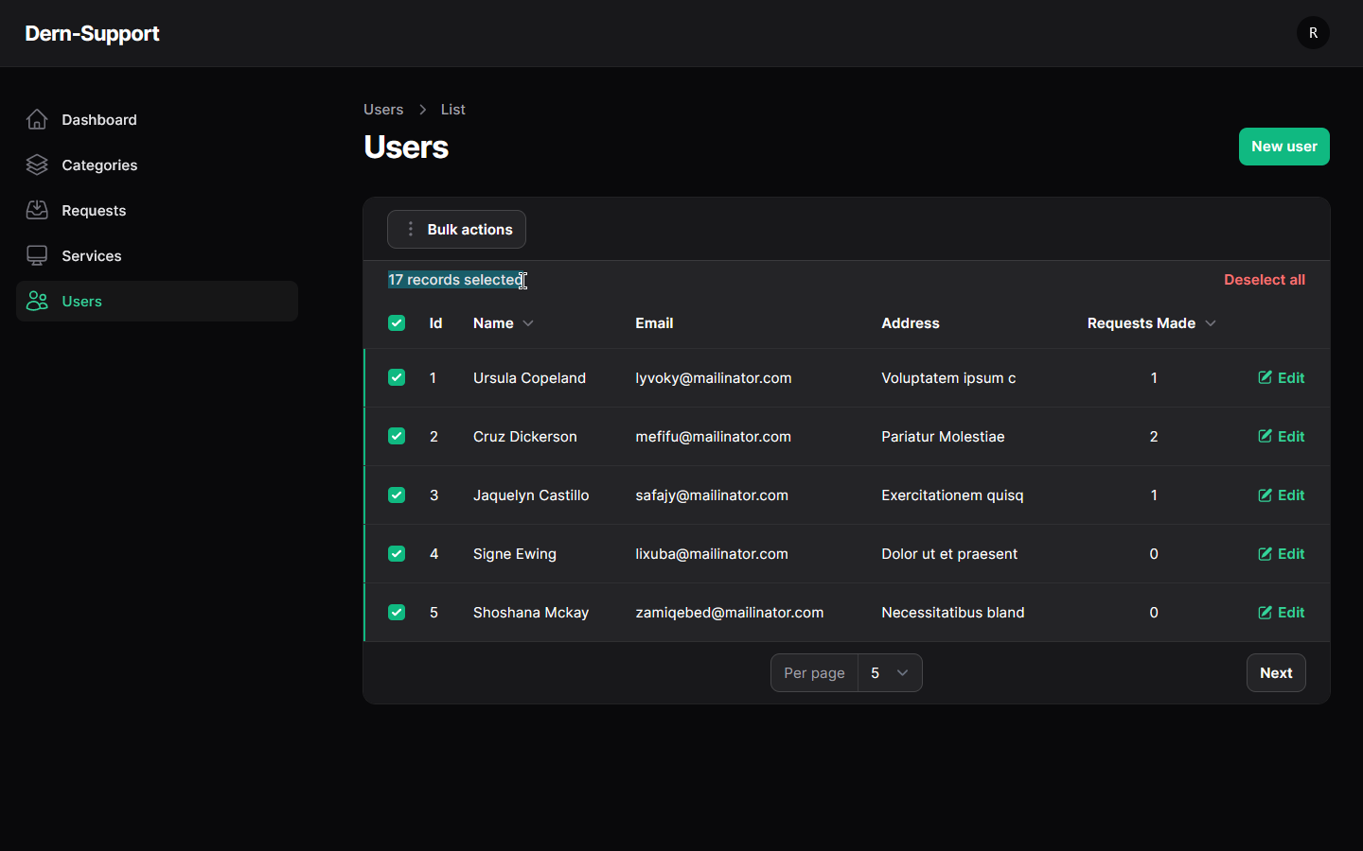

*Examples of admin login:* 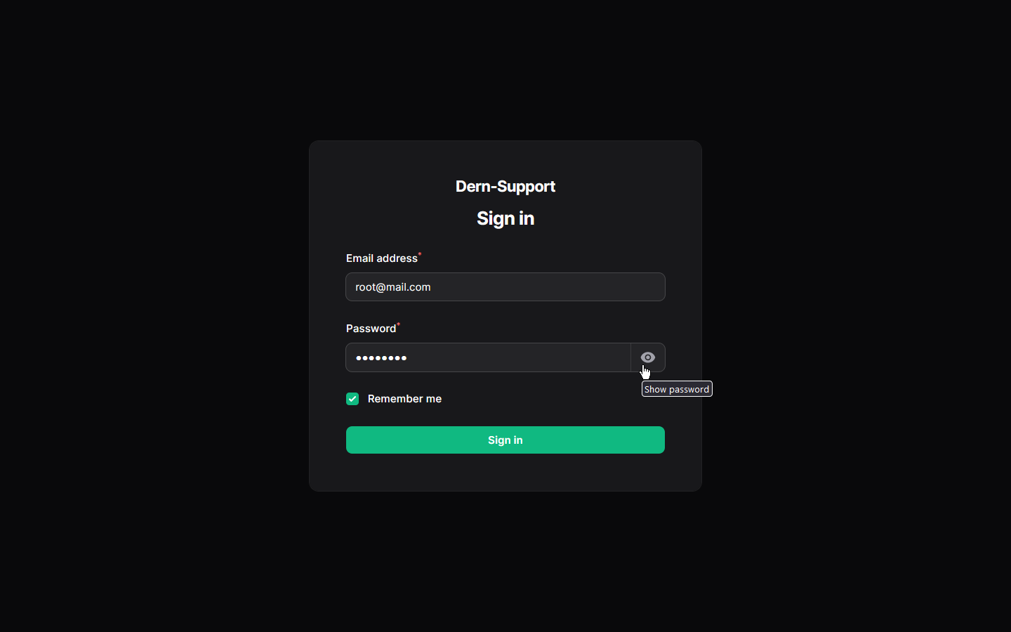

*Examples of validation messages:* 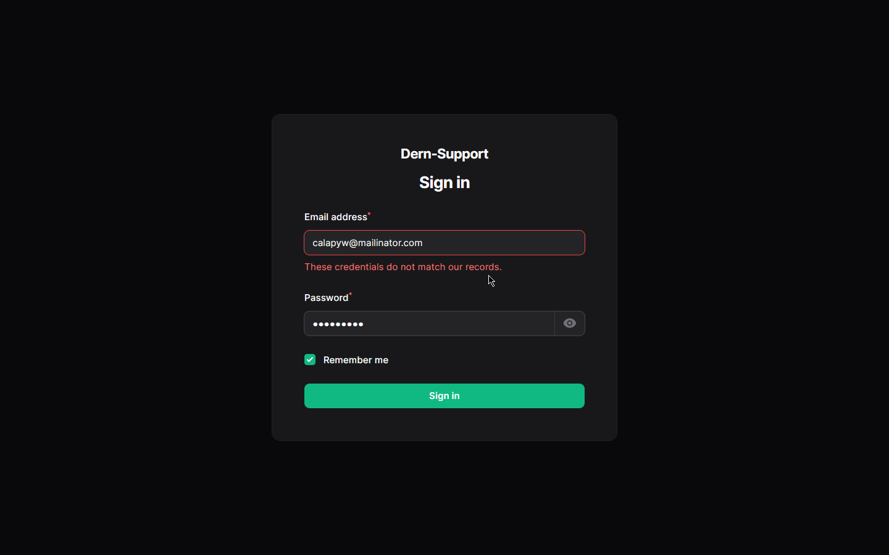

*Examples of customer login:*

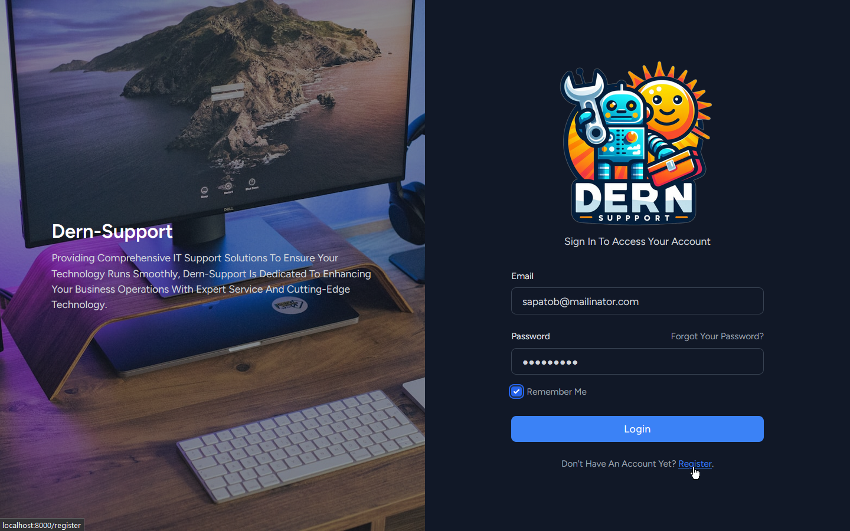

*Examples of user login validation messages:* 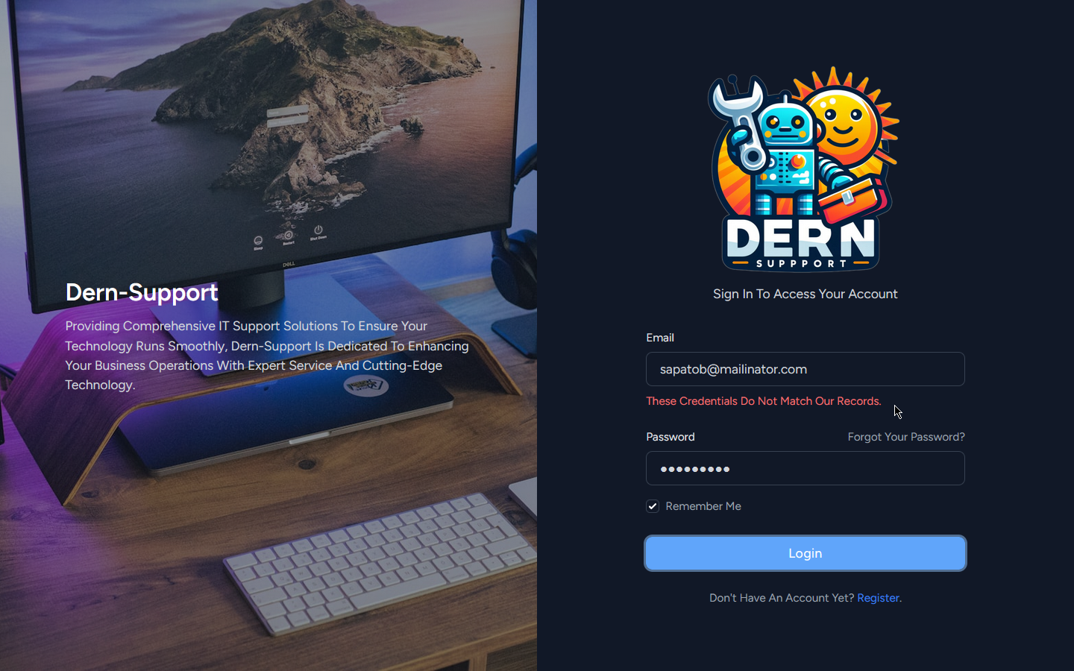

*Examples of customer registration:* 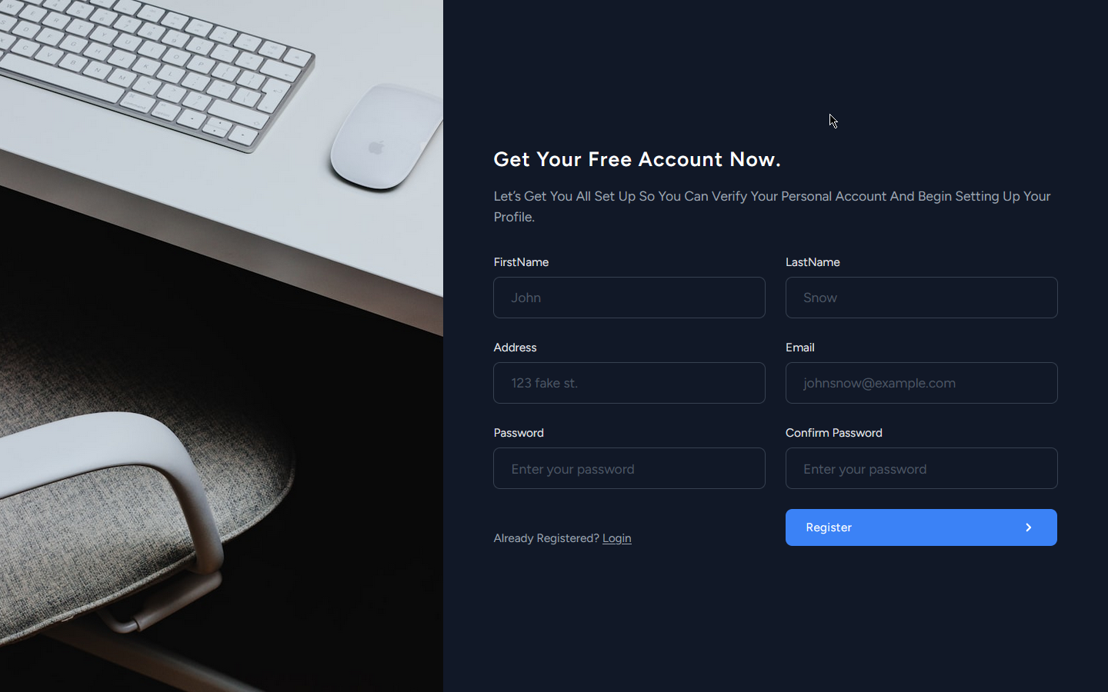 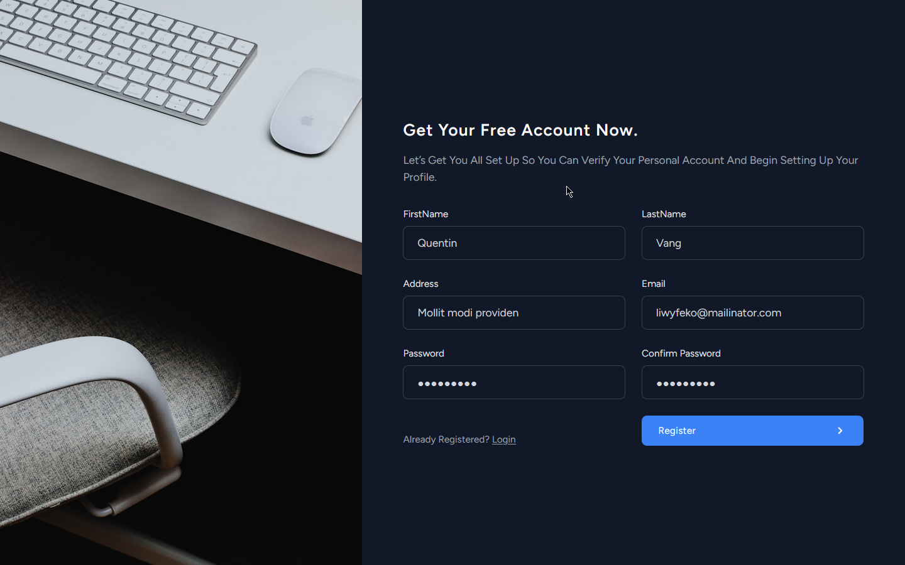

*Examples of user register validation messages:* 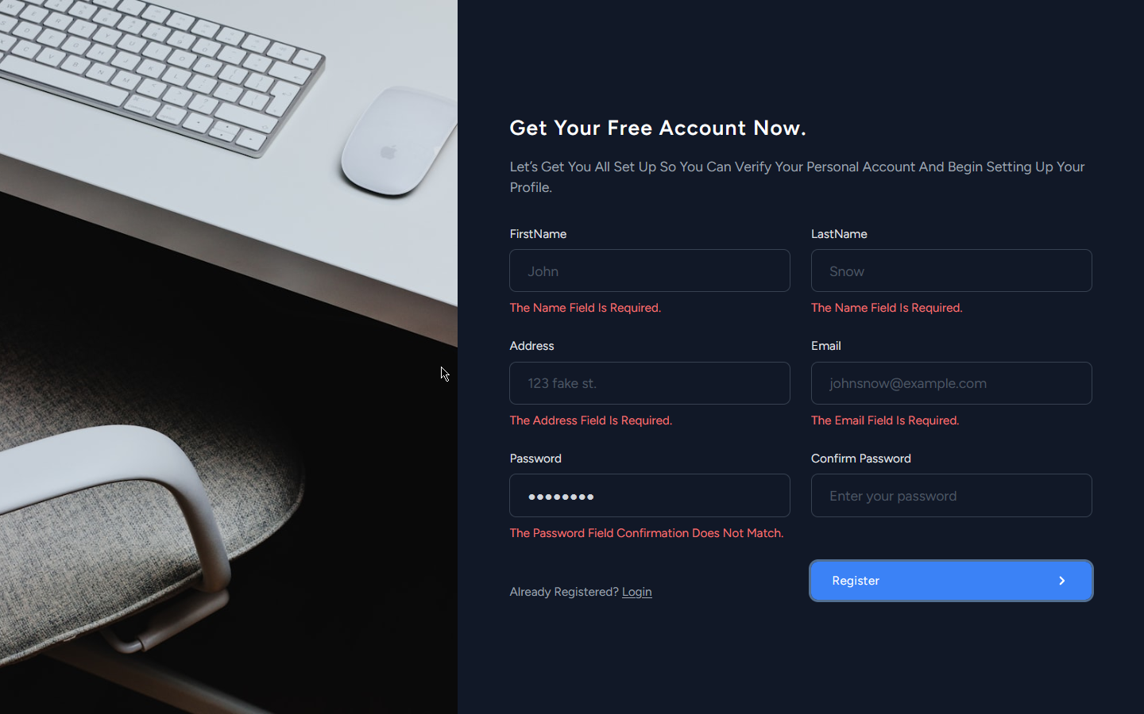

*Examples of landing page:* 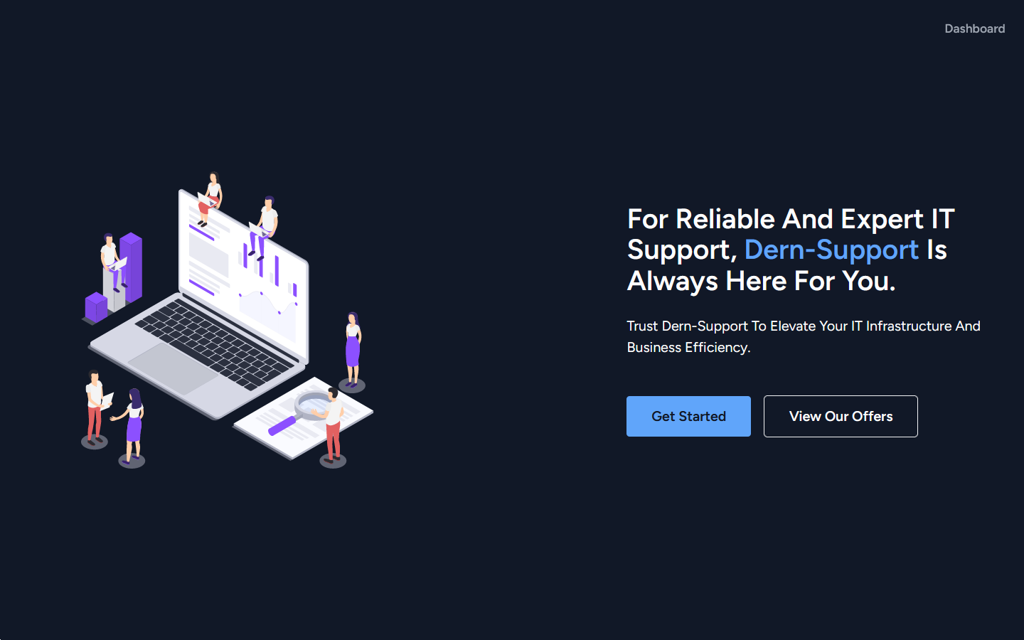

*Examples of landing page (guest layout):*

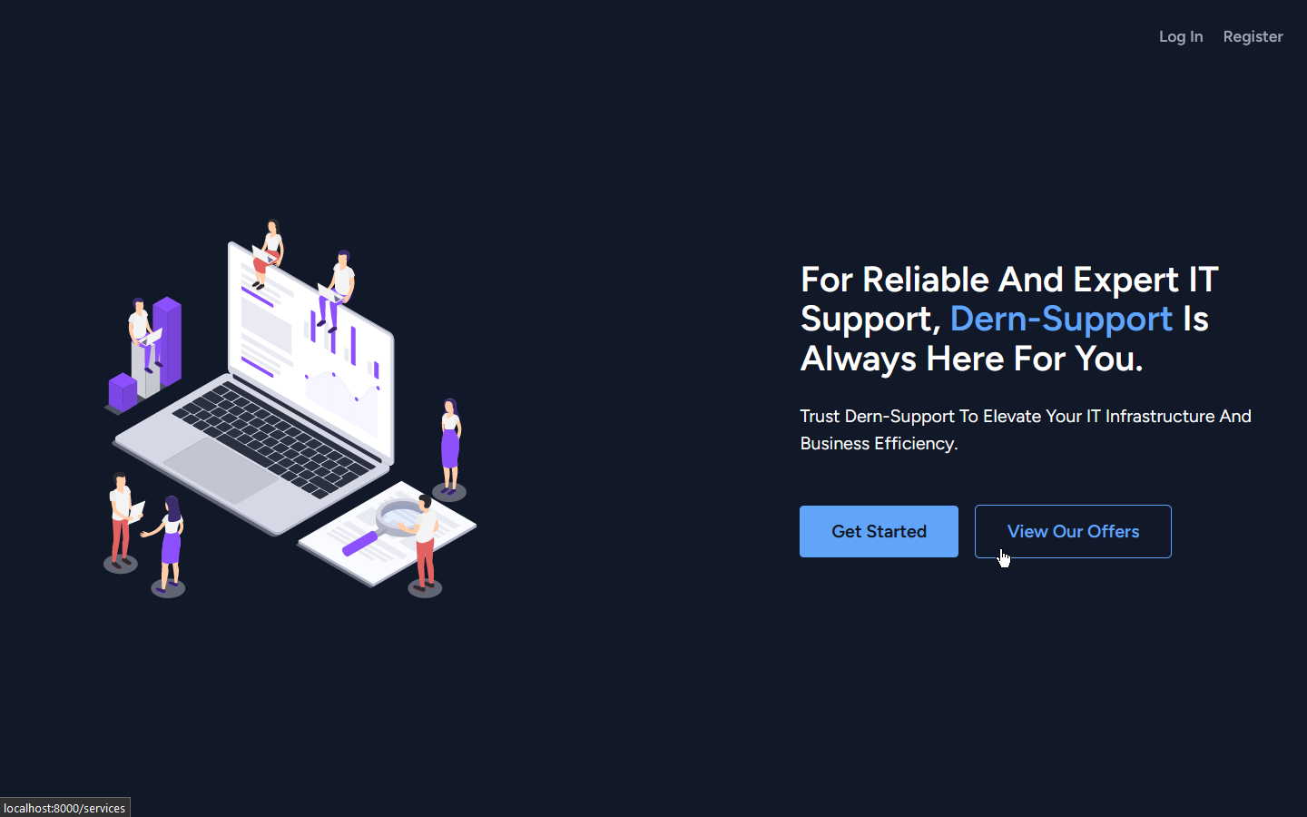

*Examples of the services page:*

View all services: 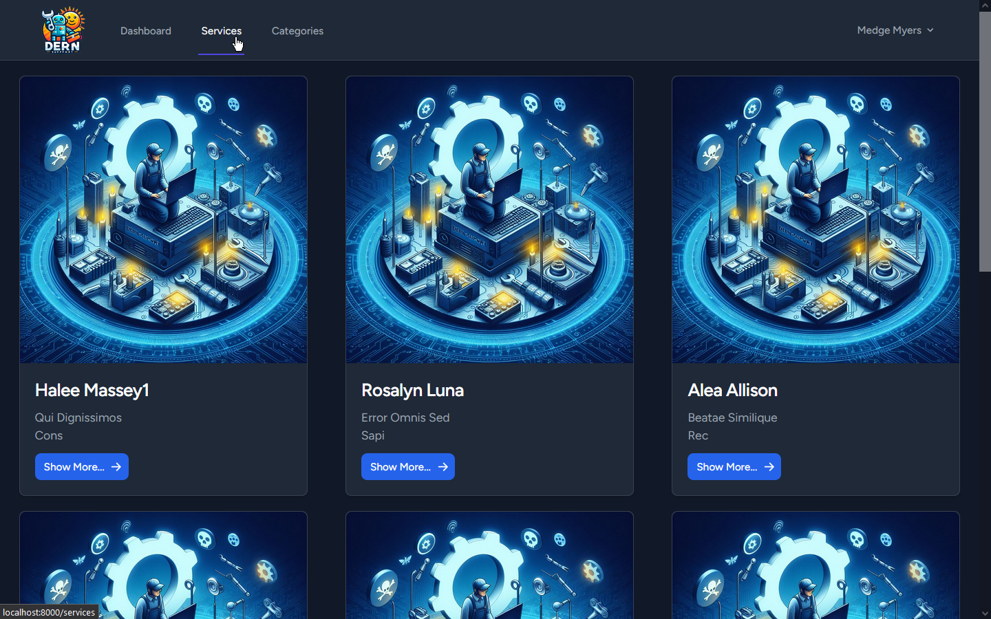View all services (no services available): 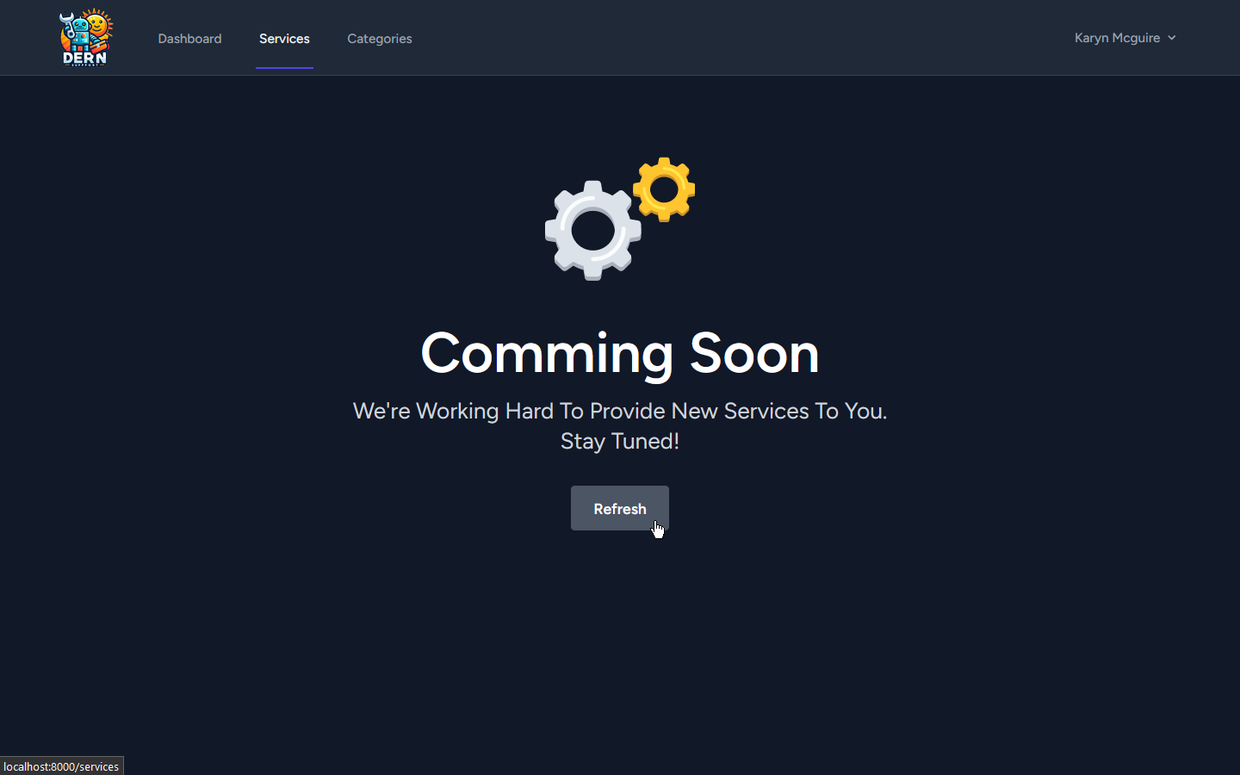

*Examples of the service details page:* 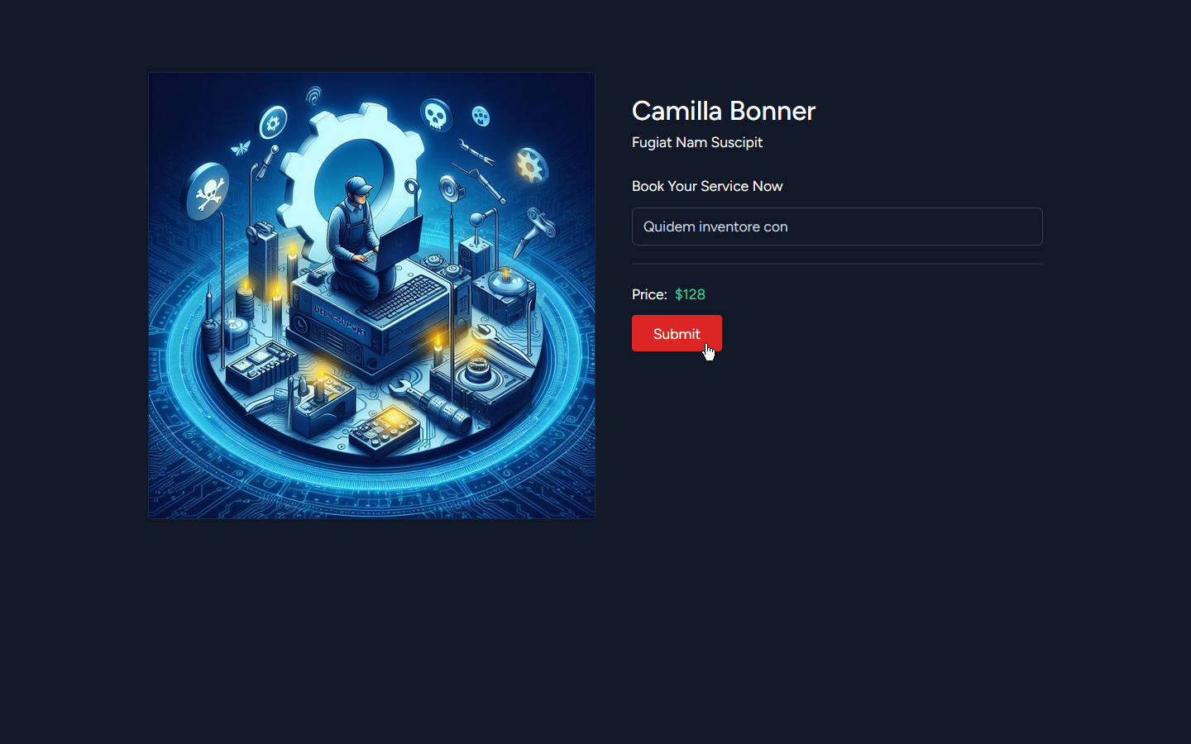

*Examples of the categories page:*

View all categories: 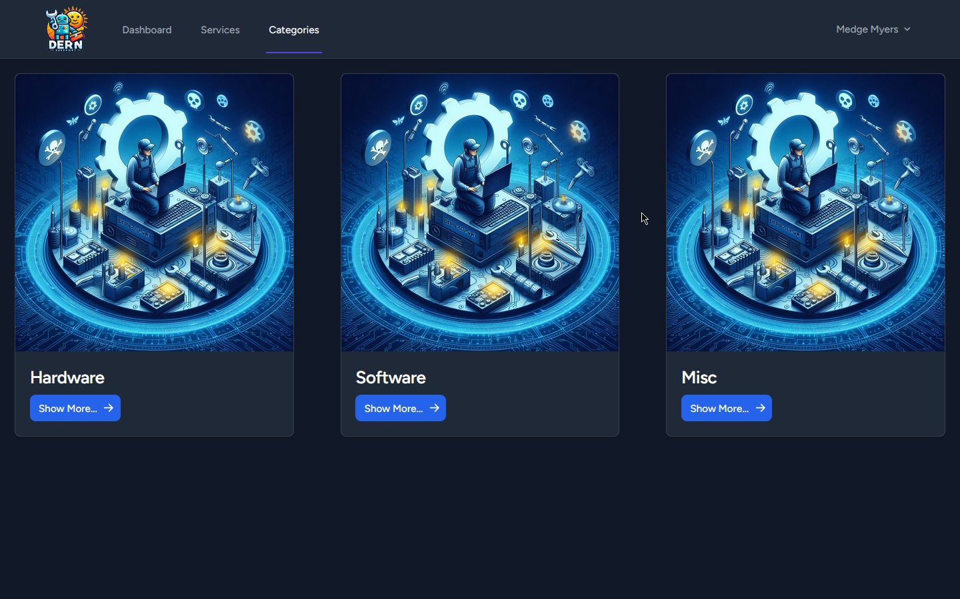View all categories (no categories available): 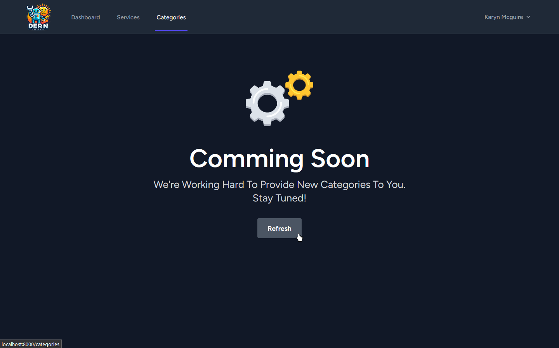

*Examples of the services by category page:* 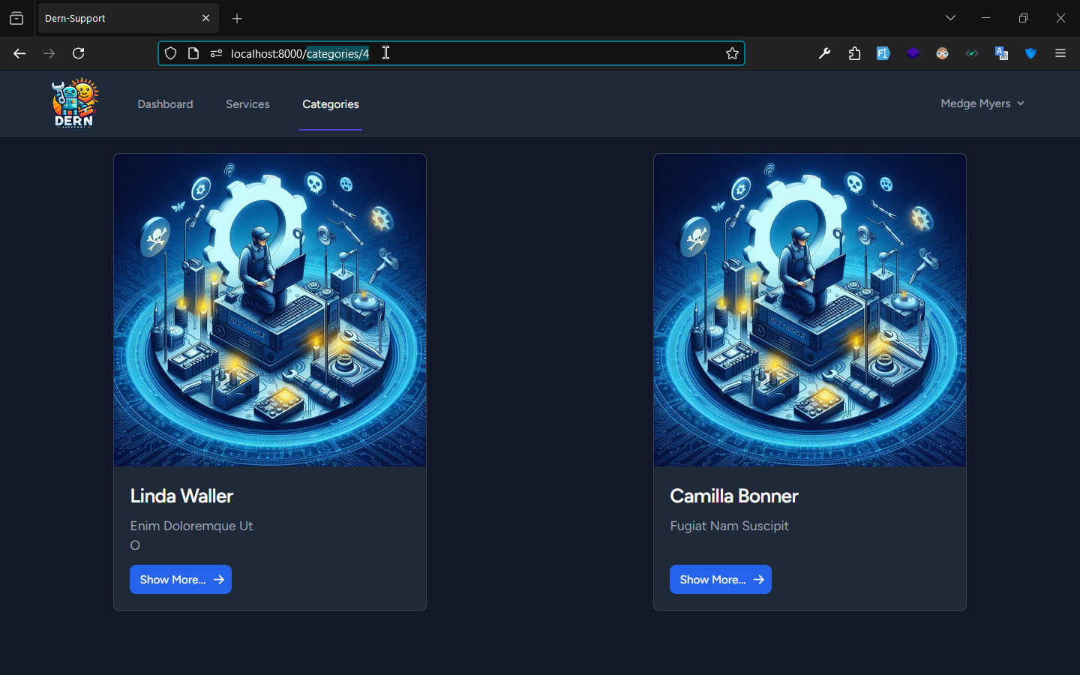

*Examples of the user dashboard:*

View all requests: 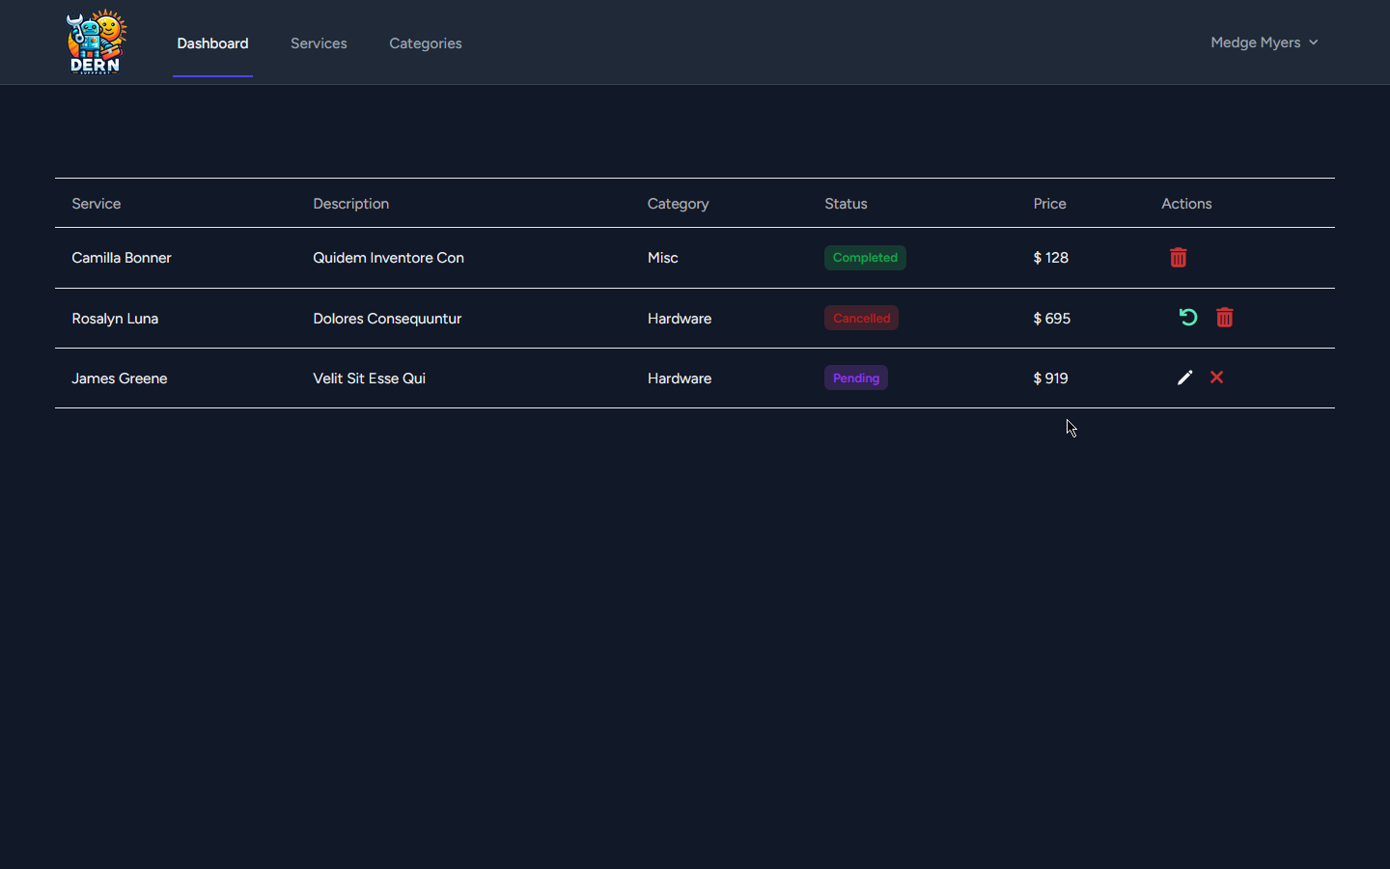View all requests (no requests made yet): 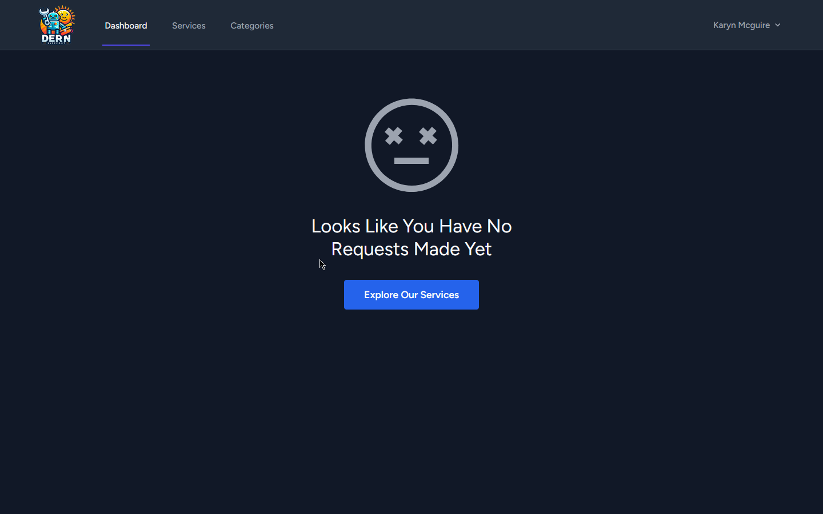

Restore cancelled requests: 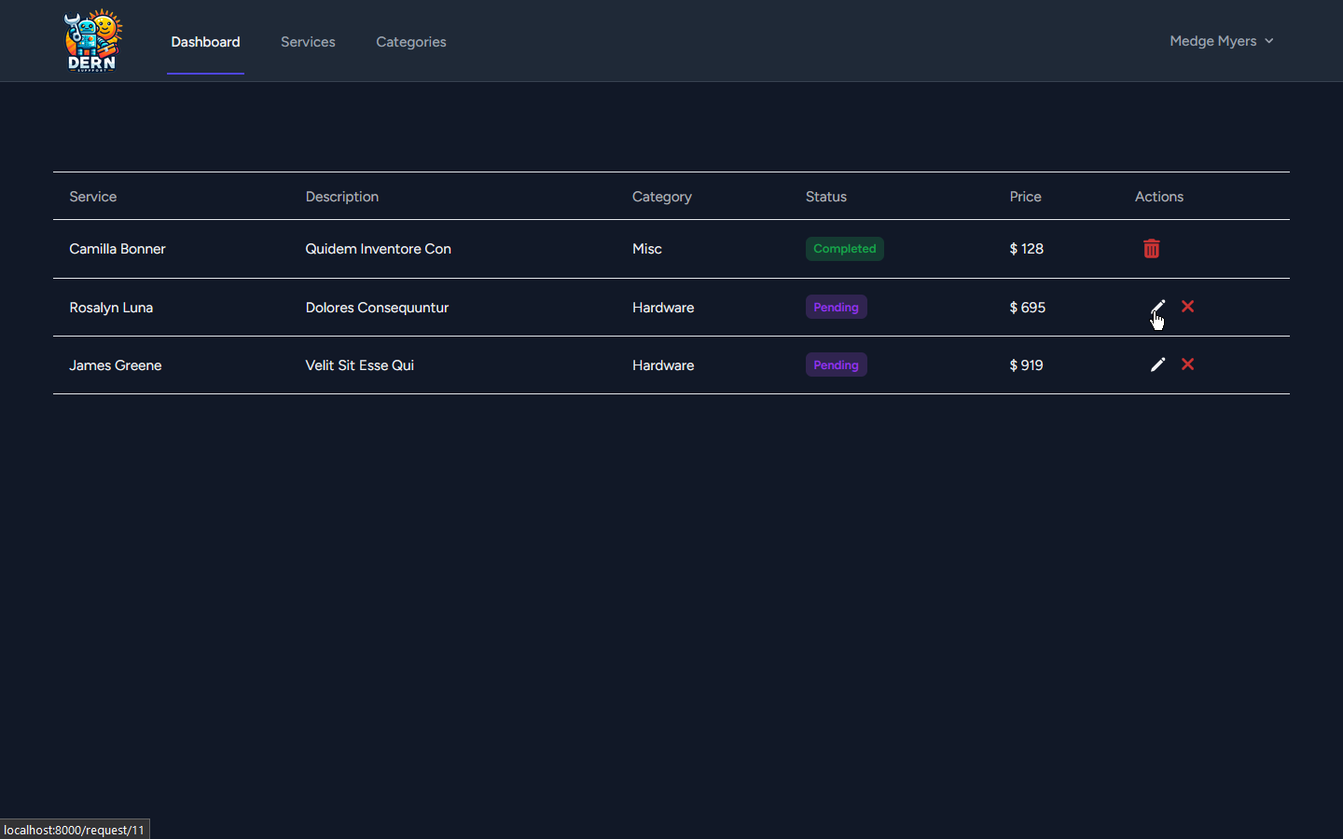

Delete cancelled request: 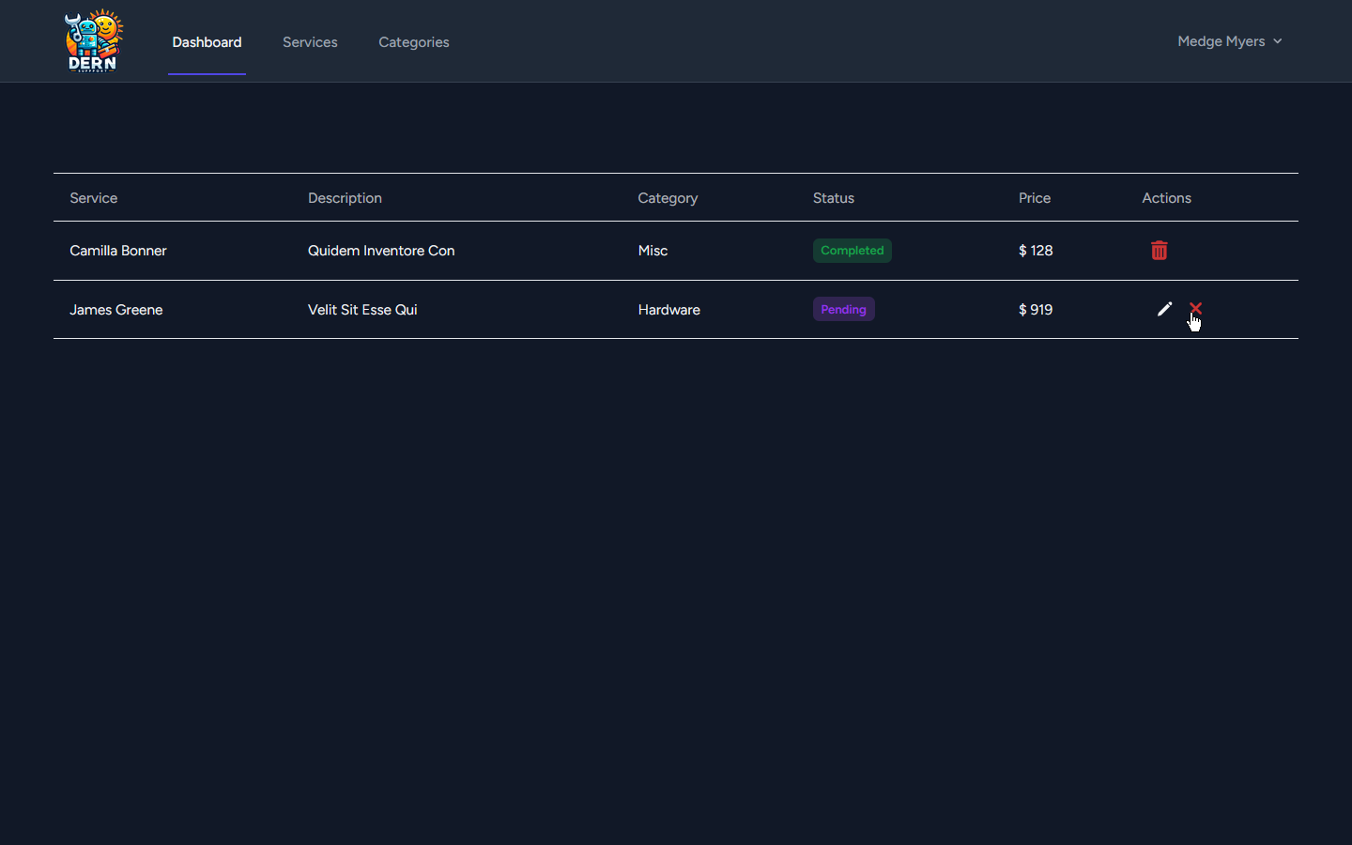

Delete completed request: 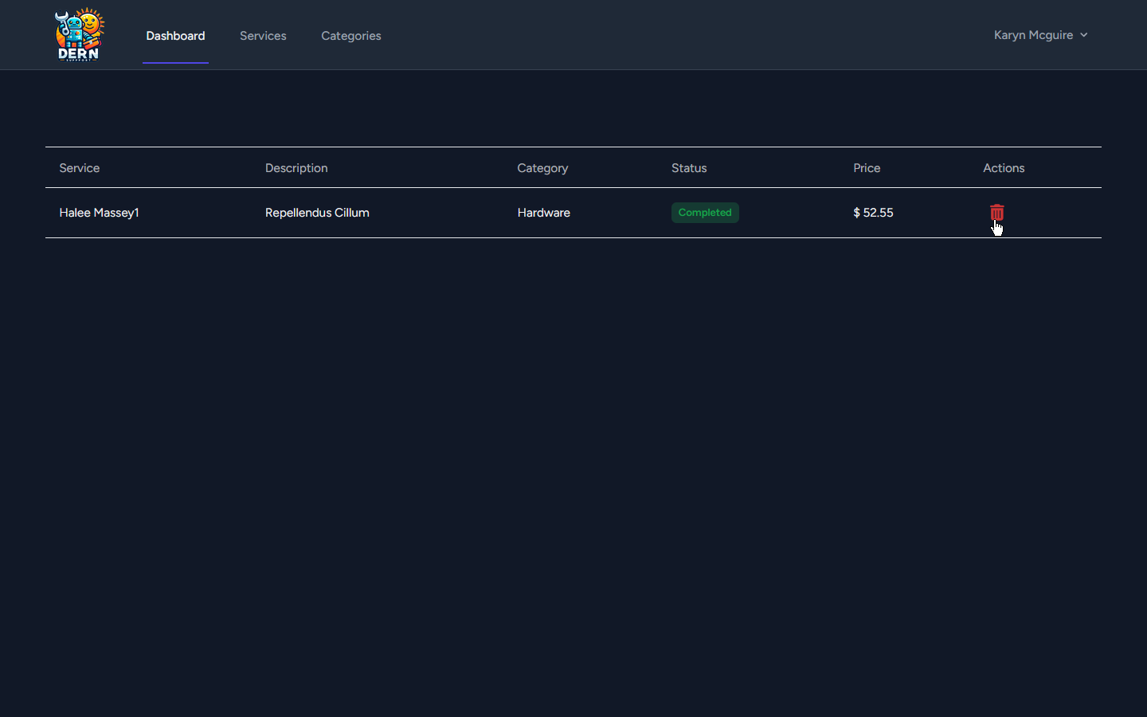Edit existing (pending) request: 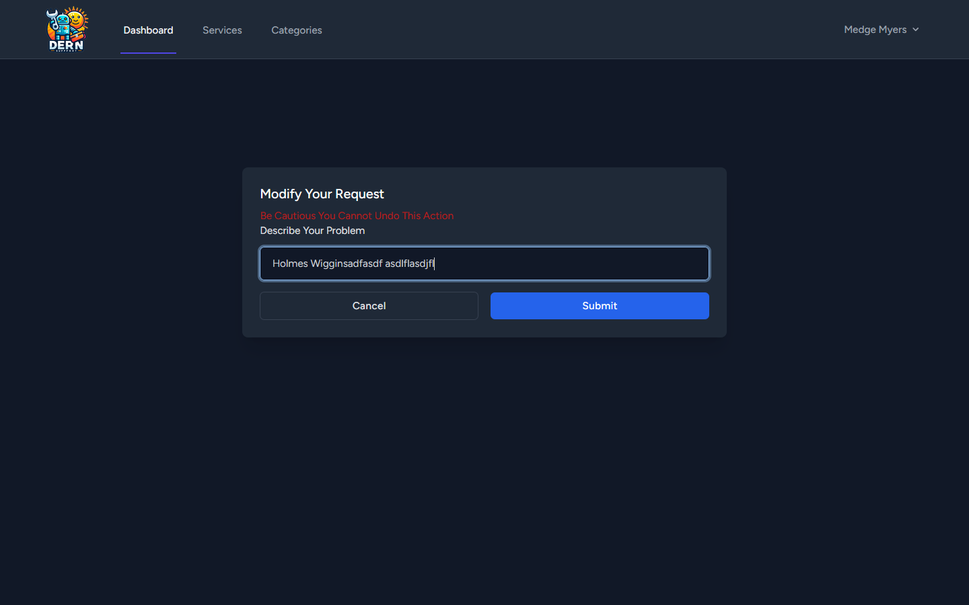

*Examples of the user profile page:*

Edit basic info: 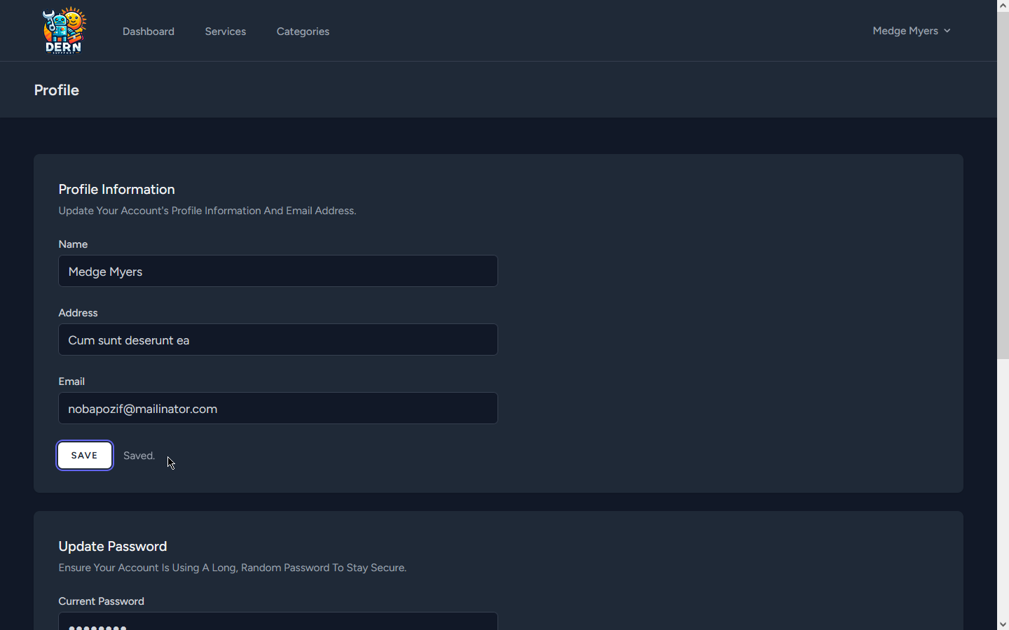Change password (successful): 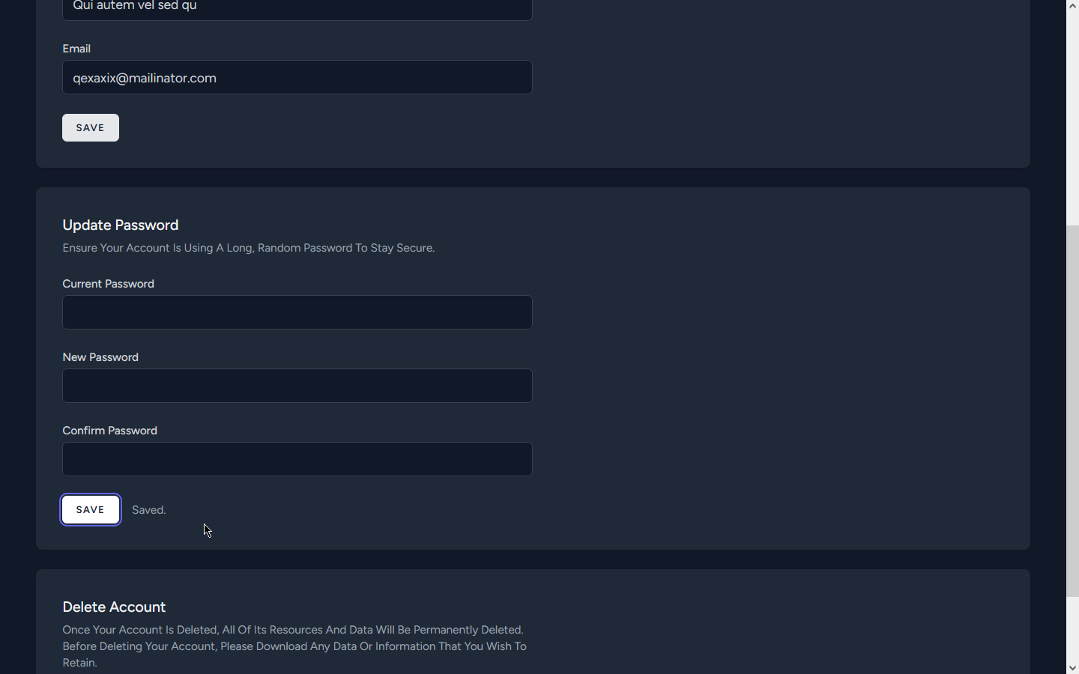

Change password (incorrect password): 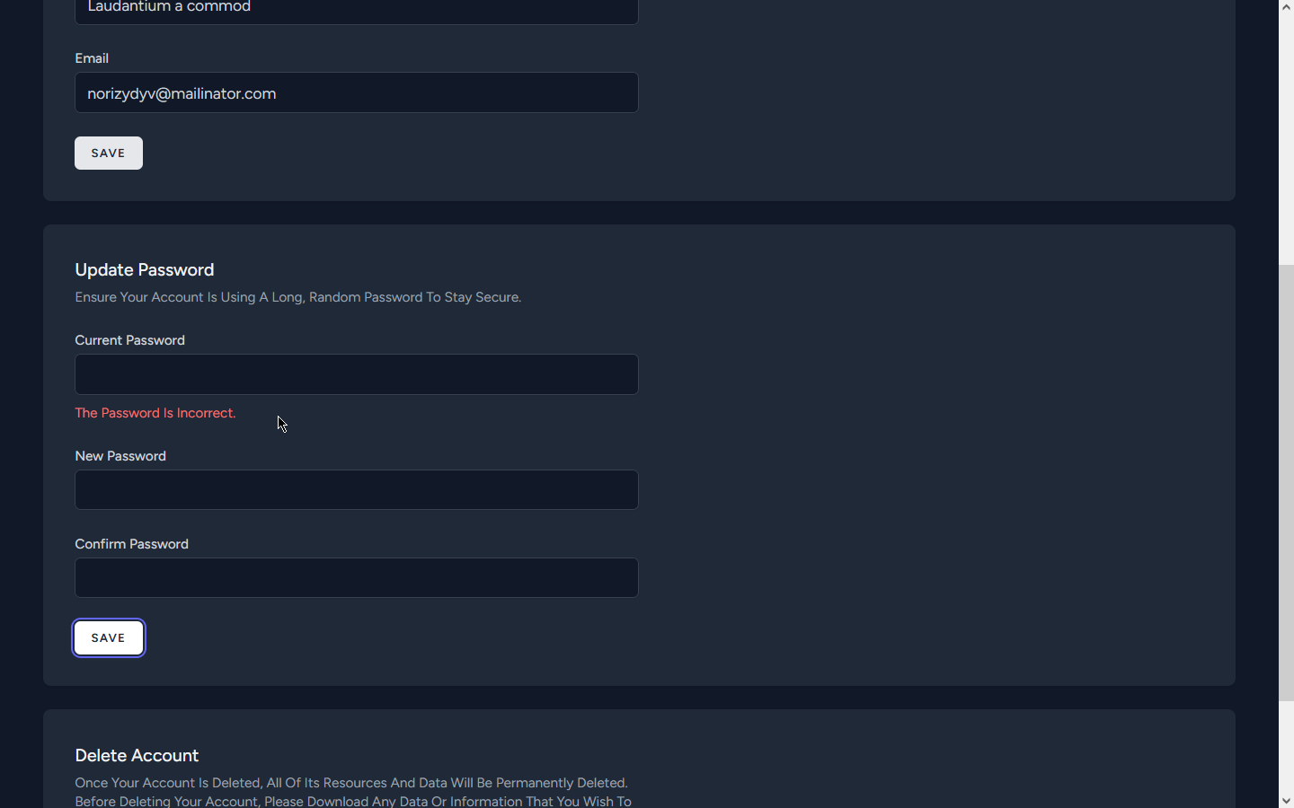Change password (passwords not matching): 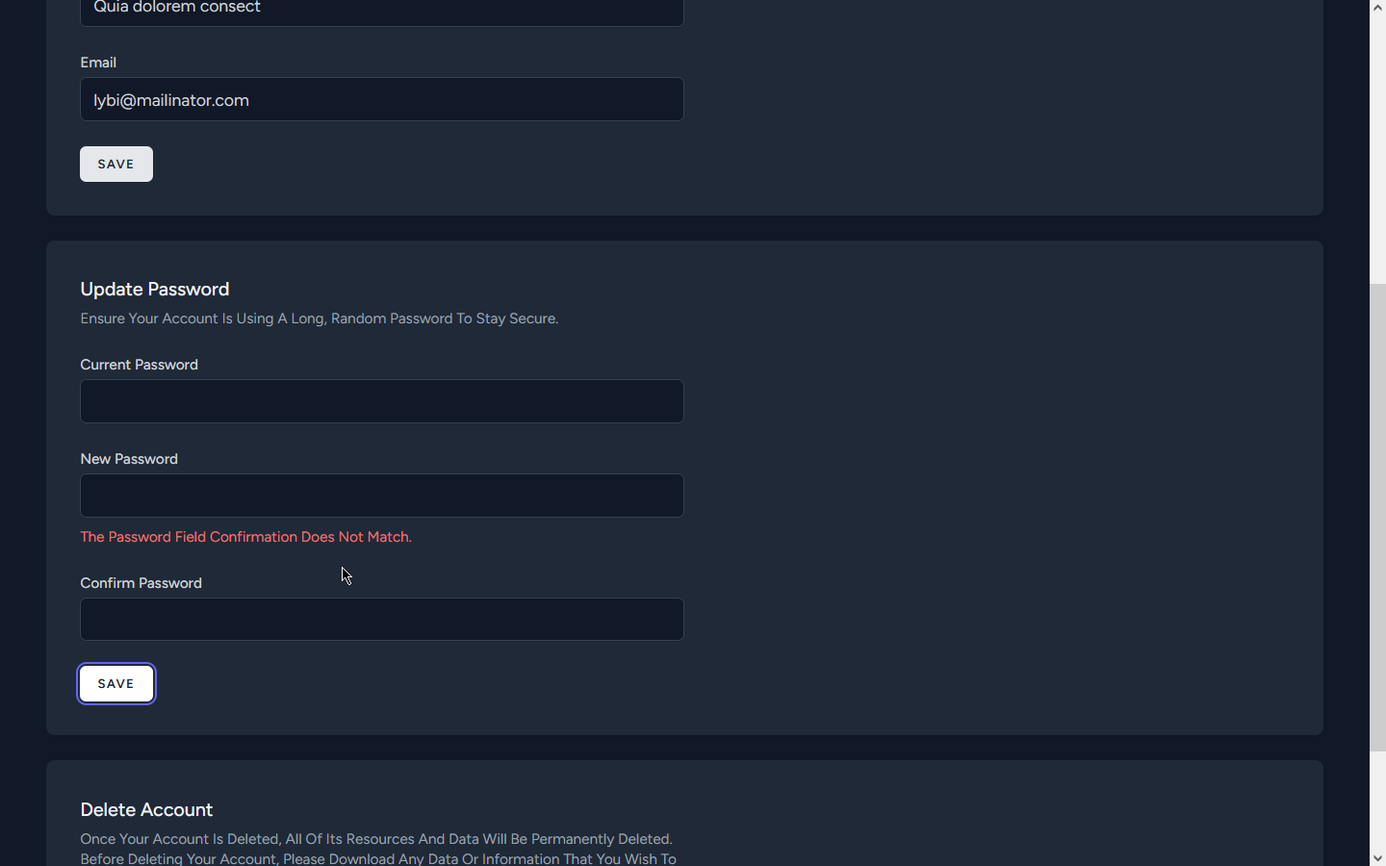

Delete account button: 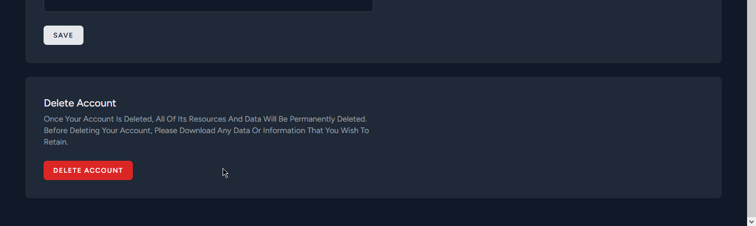Delete account modal: 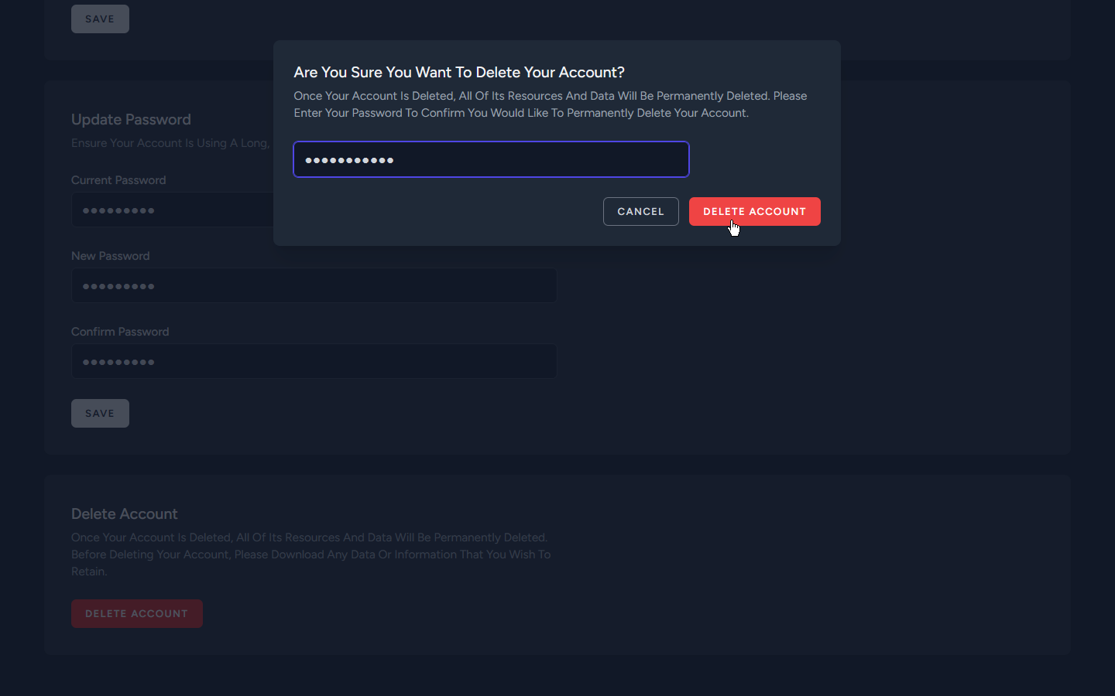

Delete account modal (wrong password): 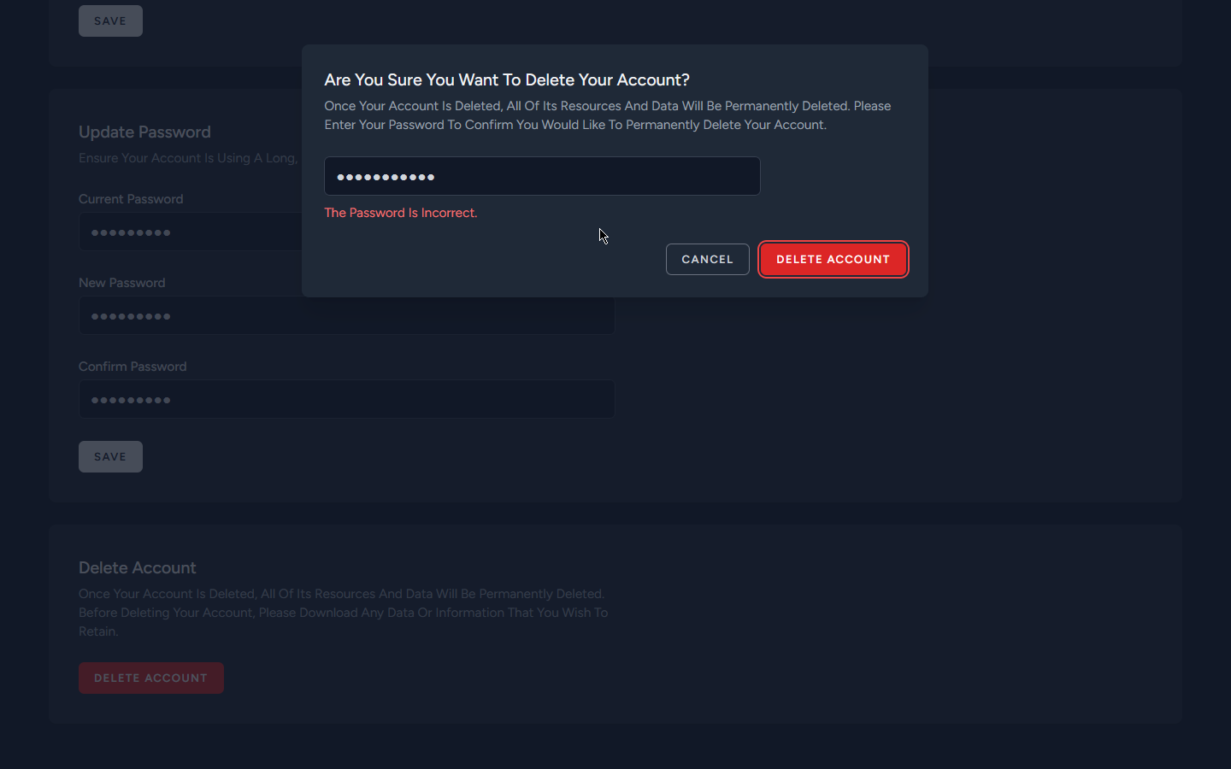Delete account modal (success redirected to the landing page): 

### Implementation Phase:

#### Coding:

I used the following technologies for the project:

* HTML (Blade Template, Livewire)
* CSS (Tailwindcss)
* JavaScript
* PHP (Laravel Framework)
* MySQL
* Git
* GitHub

I used the following libraries for the project:

* Frontend technologies:
  + Tailwindcss: A utility-first CSS framework for rapidly building custom user interfaces.
  + Hero icons: Beautiful hand-crafted SVG icons, by the makers of Tailwind CSS.
  + Laravel Livewire: A full-stack framework for Laravel that provides a simple, yet powerful way to build dynamic UIs.
* Backend technologies:
  + Filament: A collection of beautiful full-stack components. For designing the admin dashboard.
  + Eloquent: An object-relational mapper (ORM) that makes it enjoyable to interact with your database.
  + the Auth facade: A simple authentication API that provides a variety of common authentication tasks.

#### User Authentication:

* I have implemented a secure user authentication system in Laravel, utilizing hashed passwords for user security.
* I have utilized Laravel’s built-in session-based authentication tokens to ensure secure user authentication.

User Authorization:

* I have implemented middlewares to protect user and admin routes in the application.
* I have implemented a middleware that ensures only authenticated users/admins can access their respective routes.
* Unauthorized access attempts are redirected to the login page, thereby enhancing the security of the application.
* I have implemented a middleware to check if the user is guest (has logged in or registered) or not.

### Testing Phase:

* Performed integration tests for backend components, including routes, controllers, and database interactions
* Ensured proper integration of Laravel Livewire components with backend APIs in frontend integration tests.
* Evaluated system performance under different loads using tools like JMeter for testing APIs performance.
* examples on testing using JMeter:

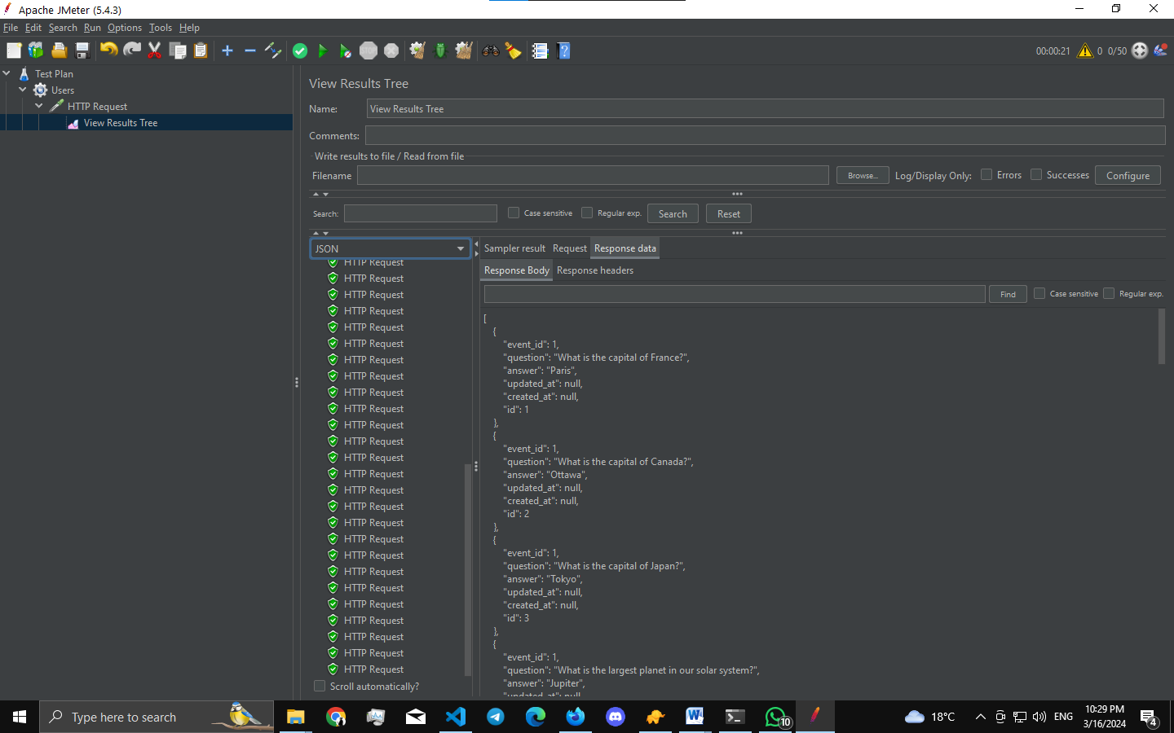

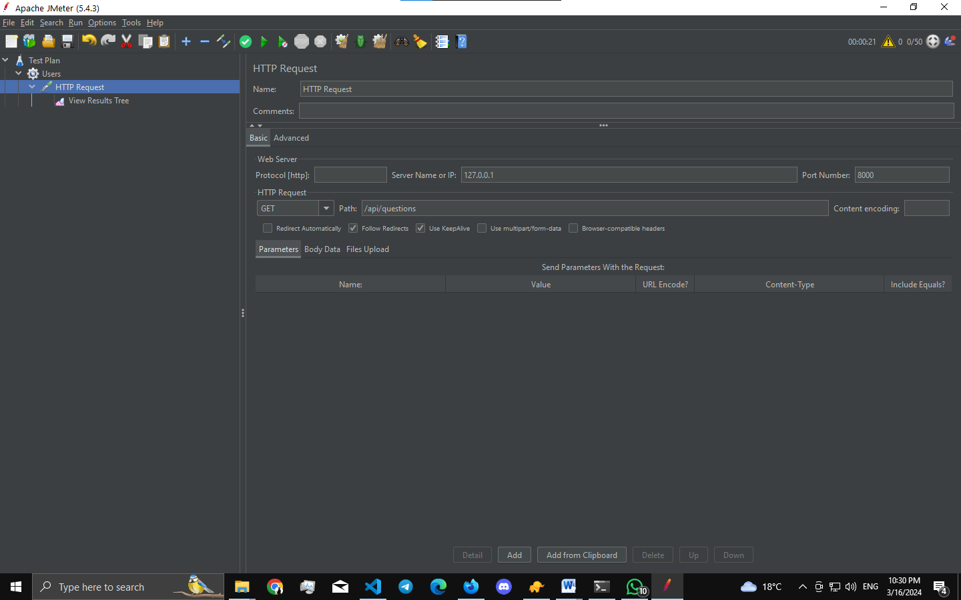

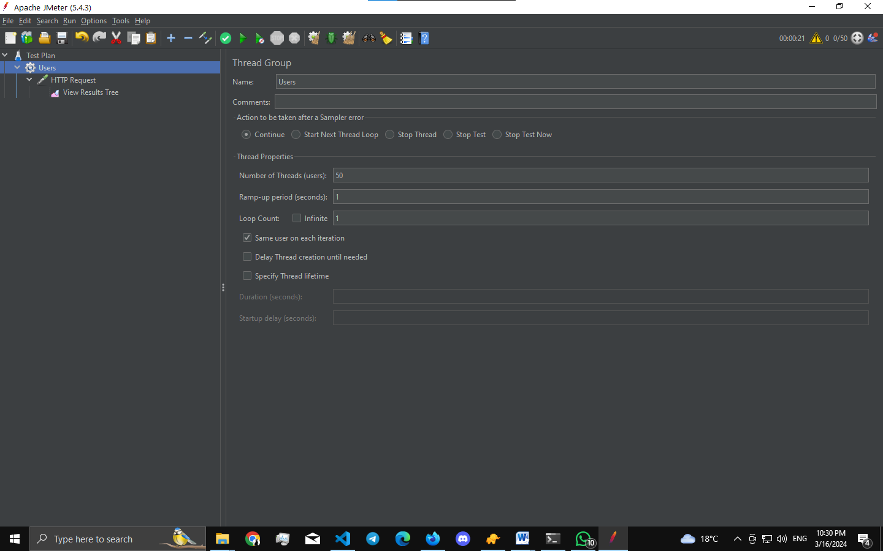

### Deployment phase:

* Deploying the app may need additional costs which isn’t available with me right now.
* there are lots of ways to deploy laravel apps I will mention two of them:
  + Laravel Vapor: serverless deployment platform for Laravel, powered by AWS. Launch your Laravel infrastructure on Vapor and fall in love with the scalable simplicity of serverless.
  + Envoyer: deploys your PHP applications with zero downtime. Just push your code, and let Envoyer deliver your application to one or many servers without interrupting a single customer.

## Maintenance Phase

### Bug Fixes

* Continuously monitor the system for any reported bugs or issues.
* Utilize Laravel’s debugging tools like Telescope to identify the root causes of problems.
* Implement and test bug fixes using Laravel’s testing suite (PHPUnit), ensuring that they do not introduce new issues.

### Performance Monitoring

* Utilize monitoring tools like Laravel Horizon or third-party services to track the system’s performance.
* Identify and address any performance bottlenecks or areas of improvement using Laravel’s profiling and optimization techniques.

### Security Updates

* Stay informed about security updates for Laravel framework and other dependencies used in the project.
* Apply security patches promptly by updating Laravel and its dependencies to the latest versions.

### Database Optimization

* Analyze and optimize database queries using Laravel’s Eloquent ORM to improve overall system performance.
* Implement indexing and caching strategies using Laravel’s caching mechanisms and query optimization techniques.

# System Design Document

## Technologies Used

* **Laravel** for the backend
* **Livewire** for frontend interactivity
* **Laravel Breeze** for authentication
* **Filament** for the administration dashboard
* **MySQL** with Eloquent ORM for database interaction
* **Tailwind CSS** for styling

## System Architecture Design

### User Authentication

* **Task:** Implement user authentication for customers and admins.
* **Algorithm:** Use Laravel’s built-in access tokens for token-based authentication.
* **Data Storage:** Store user credentials securely in the MySQL database.

### Customer Registration

* **Task:** Allow customers to register and create accounts.
* **Algorithm:** Design a registration form that collects customer information.
* **Data Storage:** Store customer information in the database.

### Service Management

* **Task:** Create functionality for managing services and their categories.
* **Algorithm:** Implement CRUD operations for services and categories, allowing admins to create, update, and delete them.
* **Data Storage:** Store service and category details in the database.

### Support Request Management

* **Task:** Develop a system for creating and managing support requests.
* **Algorithm:** Design a dynamic form for support request creation, allowing customers to select services and describe issues.
* **Data Storage:** Store support request details, including status and related service information, in the database.

### Service Pricing and Calculation

* **Task:** Define and implement a pricing system for services.
* **Algorithm:** Calculate service charges based on service type and complexity.
* **Data Storage:** Store pricing details and calculations in the database.

### Support Request Status Tracking

* **Task:** Track the status of support requests from submission to completion.
* **Algorithm:** Update request status dynamically as it progresses through different stages (pending, in progress, completed, cancelled).
* **Data Storage:** Store the current status of each support request in the database.

### Customer Dashboard

* **Task:** Provide a dashboard for customers to manage their accounts and support requests.
* **Algorithm:** Display a summary of account information, active support requests, and their statuses.
* **Data Storage:** Retrieve and display customer-specific data from the database.

## Diagrams

### Entity Relationship Diagram (ERD)

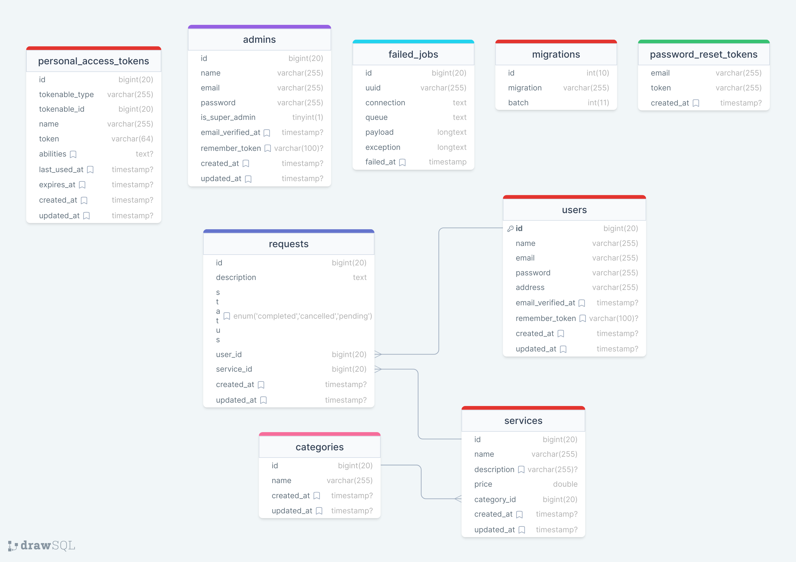

# Analysis

## Authentication and Authorization

* **Utilize Laravel access tokens** for secure authentication, providing a stateless mechanism for user identity verification.
* Implement **password hashing** using Laravel’s built-in encryption mechanisms to enhance security.
* Employ **role-based access control** to manage permissions for different user types (users, administrators).

## Database Design Analysis

* Choose **MySQL as the database** due to its robustness and compatibility with Laravel’s Eloquent ORM.
* Use **Eloquent ORM** to define schema models, ensuring consistency in data storage.
* Consider indexing and caching strategies for efficient data retrieval, especially when dealing with large amounts of customer and support request data.

## Scalability

* Design the system to handle potential future growth in terms of customer base and support requests.
* Consider load balancing strategies for the Laravel server to distribute incoming requests efficiently.

## Support Request Management

* Define a modular support request structure that supports various request types and statuses.
* Utilize a flexible design to handle different request types within the same system.
* Allow dynamic creation and modification of support requests, accommodating the company’s need for flexibility in services offered and request statuses.

## Service Pricing and Calculation

* Develop a flexible pricing algorithm that can be easily adjusted based on the company’s preferences.
* Allow for real-time calculation and display of service costs, providing transparency to customers.

## Frontend Design (Livewire and Tailwind CSS)

* Create a responsive and intuitive user interface using **Livewire components** that caters to both customers and administrators.
* Implement client-side routing for a seamless and dynamic user experience.
* Utilize **Tailwind CSS** for styling to ensure consistency and ease of maintenance.

## Backend (Laravel with Eloquent ORM)

* Design RESTful APIs for efficient communication between the frontend and backend using **Laravel’s routing system**.
* Implement middleware for authentication and authorization, utilizing **Laravel access tokens**.
* Utilize environment variables for secure configuration management.

## Testing and Debugging

* Implement a robust testing strategy, including unit tests, integration tests, and end-to-end tests.
* Utilize debugging tools provided by Laravel to identify and address issues during development and deployment.

# Advantages and Drawbacks

### Laravel (Backend)

* **Advantages**:
  + **Eloquent ORM**: Provides a simple ActiveRecord implementation for working with your database. Each database table has a corresponding “Model” which is used to interact with that table.
  + **MVC Architecture**: Laravel follows the MVC pattern, ensuring clarity between logic and presentation. This design pattern allows changes to be made to the UI without affecting the business logic and vice versa.
* **Drawbacks**:
  + **Learning Curve**: Laravel comes with its own directory structure which could be overwhelming for new developers.

### Livewire

* **Advantages**:
  + **Simplicity**: Livewire allows you to build dynamic interfaces directly from Laravel blade views, simple directives are used in the blade views.
* **Drawbacks**:
  + **Performance**: Livewire can be slower compared to a solution implemented in Vue.js or React.js.

### Filament

* **Advantages**:
  + **Admin Panel**: Filament is a set of tools for rapidly building beautiful TALL stack interfaces.
* **Drawbacks**:
  + **Limited Community Support**: As Filament is relatively new, the community support might not be as extensive as other established packages.

### MySQL using Eloquent ORM

* **Advantages**:
  + **ACID Compliance**: MySQL is ACID compliant which ensures the reliability of transactions.
  + **Popularity**: MySQL is widely adopted, and there exists a large community of developers who can help answer questions or resolve issues.
* **Drawbacks**:
  + **Scaling**: While MySQL can be scaled, it’s not as easy to do as with some NoSQL databases.

### Autoprefixer, PostCSS, PostCSS-Nesting

* **Advantages**:
  + **Browser Compatibility**: Autoprefixer adds vendor prefixes to your CSS so that styles work across different browsers.
  + **Advanced Transformations**: PostCSS allows you to use tomorrow’s CSS syntax today, and PostCSS-Nesting enables nested CSS rules.
* **Drawbacks**:
  + **Additional Build Steps**: These tools add additional steps to your build process.

### Axios

* **Advantages**:
  + **Simplicity**: Axios provides a simple API for making HTTP requests and works great with Vue.js.
* **Drawbacks**:
  + **Overhead**: For simple projects, the additional features of Axios might be unnecessary.

### Laravel Vite Plugin, Tailwind CSS, and Vite

* **Advantages**:
  + **Performance**: Vite provides a faster and leaner development experience for modern web projects. It works great with Vue.js and Laravel.
  + **Utility-First**: Tailwind CSS is a utility-first CSS framework which is highly customizable and works very well with modern JavaScript frameworks.
* **Drawbacks**:
  + **Learning Curve**: There might be a learning curve associated with understanding these tools and how to configure them properly.

## Integration

* **Laravel + Livewire + Filament**: The combination of Laravel, Livewire, and Filament can provide a seamless stack for building web applications.
* **Eloquent ORM with MySQL**: Eloquent ORM simplifies interaction with MySQL, providing a convenient and expressive way to model data.

## Pre-defined Code

* **For user authentication**, you can leverage existing libraries such as Laravel’s built-in authentication, saving development time.
* **Various Laravel packages** are available for handling HTTP requests, user authentication, and event handling.

## Assets

* **Livewire Components**: Utilize existing Livewire component libraries for UI elements and styling.
* **Support and Service Data**: If predefined support requests/services exist, they can be integrated directly into the system, possibly as JSON files.

# Review and Feedback

## Initial Design Overview

* Presented the initial design to the team, highlighting the use of Laravel for the backend, Livewire for dynamic interfaces, Filament for admin interfaces, MySQL with Eloquent ORM for database interactions, and Laravel Vite Plugin, PostCSS, PostCSS-Nesting, Tailwind CSS, and Vite for frontend development.
* Emphasized the flexibility and scalability of the chosen technologies for handling the service’s diverse requirements.

## Functional Flow

* Walked through the entire functional flow of the application, detailing how customers can register, submit support requests, and manage their accounts.
* Discussed the seamless integration of support request management, ensuring a smooth user experience.

## Security Measures

* Highlighted the use of Laravel’s built-in authentication and security features, emphasizing the importance of data security, especially when handling user information and support requests.

## User Experience

* Discussed the user interface implemented with Livewire and Tailwind CSS, focusing on the user experience and intuitive navigation for both customers and administrators.
* Demonstrated the responsive design to ensure accessibility on various devices.

## Scalability and Performance

* Addressed potential scalability concerns, particularly considering the dynamic nature of the support request system with varying numbers of customers and requests.
* Discussed strategies for optimizing database queries and ensuring efficient server-side processing with Laravel and Eloquent ORM.

## Feedback Collection

* Encouraged team members to provide feedback on the overall design, functionality, and user experience.
* Actively sought suggestions for improvements and alternative approaches to any potential bottlenecks or challenges.

## Documentation Review

* Ensured that the project documentation was comprehensive, covering technical aspects, API documentation, and user guides.
* Encouraged feedback on the clarity and completeness of the documentation.

## Iterative Refinement

* Incorporated feedback into iterative design refinements, addressing any identified areas for improvement.
* Maintained an open line of communication to discuss design decisions and make adjustments based on collective input.

# Test Plan

## 1. Unit Testing

### a. Frontend (Livewire, Tailwind CSS, Vite)

* **Components**: Test each Livewire component for rendering, state management, and proper handling of user interactions.
* API Integration: Ensure that API calls return the expected responses.

### b. Backend (Laravel, Eloquent ORM)

* **Routes**: Test each API endpoint for proper request handling and response.
* **Controllers**: Verify that controllers handle business logic correctly.
* **Database Operations**: Test CRUD operations on the database using Eloquent ORM.
* **Authentication and Authorization**:
  + **Laravel Access Tokens**: Test token generation, verification, and expiration.

## 2. Integration Testing

### a. Frontend-Backend Integration

* Ensure that Livewire components interact correctly with backend APIs.

### b. Database Integration

* Verify that data is properly stored and retrieved from the MySQL database.

## 3. End-to-End Testing

### a. User Flows

* Test common user flows, such as user registration, support request creation, and account management.
* Verify that users can submit support requests and manage their accounts accurately.

### b. Security

* Test for security vulnerabilities, such as SQL injection, cross-site scripting, and ensure that sensitive information is properly secured.

## 4. Performance Testing

### a. API Performance

* Test the API endpoints under various loads to ensure optimal performance.

### b. UI Responsiveness

* Verify that the UI remains responsive

under different usage scenarios.

## 5. Usability Testing

### a. User Experience

* Conduct usability testing sessions with potential users to gather feedback on the user interface and overall experience.
* Ensure that the UI is intuitive and easy to navigate.

## 6. Regression Testing

* Regularly test existing functionality after new features or updates are introduced to ensure that nothing is broken.

## 7. Automated Testing

### a. CI/CD Integration

* Integrate automated tests into the CI/CD pipeline to ensure continuous quality.

### b. Test Coverage

* Aim for comprehensive test coverage to catch potential issues early.

## 8. User Acceptance Testing (UAT)

* Conduct UAT sessions with stakeholders to validate that the system meets their requirements and expectations.

## 9. Documentation Testing

* Ensure that the technical and user documentation is accurate and up-to-date.
* Verify that documentation covers all aspects of the system, including installation, configuration, and usage.

## 10. Bug Reporting and Tracking

* Implement a system for tracking and managing bugs discovered during testing.
* Ensure that all reported bugs are addressed and resolved promptly.

By following this comprehensive test plan, we can ensure that the software solution for Dern-Support is robust, reliable, and user-friendly.

# Repairing the Errors

## Identifying and Documenting Errors

* **Review Test Reports**: Analyzed test reports to identify all errors encountered during testing.
* **Detailed Documentation**: Documented each error with the following details:
  + Clear description of the error.
  + Steps to reproduce the error.
  + Expected behavior versus observed issues.
  + Screenshots or logs (if applicable).

## Prioritizing and Categorizing Errors

* **Severity Assessment**: Assessed the severity of each error based on its impact on functionality.
* **Error Categorization**: Categorized errors into:
  + Frontend issues (Livewire, Tailwind CSS, Vite).
  + Backend issues (Laravel, Eloquent ORM, MySQL).
* **Priority Assignment**: Assigned priority levels to errors:
  + High: Critical errors affecting core functionality.
  + Medium: Errors with moderate impact on user experience.
  + Low: Minor issues or aesthetic bugs.

## Version Control

* **Git Implementation**: Ensured the codebase was under version control using Git.
* **Branch Management**: Created separate branches for bug fixes to manage changes effectively.
* **Commit Practices**: Made frequent, descriptive commits for each change to track progress and facilitate rollback if needed.

## Backend Repairs

* **API Fixes**:
  + Addressed issues with API endpoints, ensuring proper request handling and response.
  + Fixed data flow issues to maintain data integrity and security.
* **Eloquent ORM**:
  + Corrected database interactions using Eloquent ORM.
  + Ensured models and relationships were properly defined and functioning.
* **Security Enhancements**:
  + Verified and improved security measures.
  + Ensured proper handling of authentication tokens and user data.
* **Documentation**:
  + Updated backend documentation with code changes and explanations.
  + Included updated code snippets where necessary.

## Frontend Repairs

* **Livewire Component Fixes**:
  + Fixed rendering issues and ensured proper state management in Livewire components.
  + Ensured data binding and user interactions were functioning correctly.
* **UI Improvements**:
  + Addressed issues with UI elements to ensure proper display and responsiveness.
  + Fixed CSS issues related to Tailwind CSS and ensured consistent styling.
* **Client-Side Debugging**:
  + Used browser developer tools to trace and fix frontend issues.
* **Documentation**:
  + Documented changes in Livewire components.
  + Provided updated component snippets and explanations.

## Revising Authentication Mechanism

* **User Authentication**:
  + Verified and improved the implementation of Laravel’s built-in authentication.
  + Ensured secure handling of user login, registration, and password management.
* **Access Control**:
  + Checked and fixed issues related to user authorization and role-based access control.
  + Ensured proper permissions for different user roles (e.g., admin, customer).

## Database Fixes

* **Data Integrity**:
  + Reviewed and corrected database interactions to ensure data consistency.
  + Fixed issues with data retrieval and storage.
* **Schema Adjustments**:
  + Made necessary schema changes to address structural issues.
  + Ensured proper indexing and relationships.
* **Migration Updates**:
  + Updated database migrations to reflect changes.
  + Ensured smooth execution of migrations without data loss.

## Testing and Debugging

* **Thorough Testing**:
  + Conducted extensive testing after implementing repairs to validate fixes.
  + Used unit tests, integration tests, and end-to-end tests.
* **Debugging Tools**:
  + Utilized Laravel debugging tools to trace backend issues.
  + Used browser developer tools for frontend debugging.

## Documentation of Repairs

* **Comprehensive Documentation**:
  + Created detailed documentation for each repair made.
  + Included code changes, explanations, and potential impacts on other parts of the system.
  + Ensured documentation was clear, concise, and easily accessible for future reference.

## Retesting

* **Validation of Fixes**:
  + Conducted a series of retests to ensure the effectiveness of the repairs.
  + Retested all identified error scenarios to confirm resolution.
* **New Issues Documentation**:
  + Documented the results of retesting.
  + Identified and addressed any new issues that arose during retesting.
* **Continuous Feedback Loop**:
  + Maintained a continuous feedback loop with testers to quickly identify and fix any additional issues.

# Suggestions for Future Reference

## Centralized State Management

* **Implementation**:
  + Utilize **Laravel’s service container** for centralized state management to ensure consistent and efficient handling of application state.
  + **Design a state structure** that meets the application’s needs, providing clear and efficient state transitions and management.

## Consistent Authentication

* **Implementation**:
  + Ensure consistent handling of **user authentication** across all components by leveraging Laravel’s built-in authentication mechanisms.
  + Use secure methods such as **Laravel Sanctum** or **Passport** for API token authentication, ensuring robust security practices.

## Effective Use of Laravel Features

* **Implementation**:
  + **Familiarize with Laravel’s features**: Understand and effectively use Laravel’s service container, middleware, event broadcasting, and task scheduling.
  + **Lifecycle Methods**: Utilize lifecycle methods for controllers and models to manage component behavior efficiently.

## Documentation and Comments

* **Implementation**:
  + Maintain clear and concise **documentation** for each component and functionality, including API documentation and user guides.
  + Use **comments** in the codebase to explain complex logic or functionalities, making it easier for future developers to understand and maintain the code.

# Conclusion

The Service Management System has reached an 85% completion stage, with a commitment to addressing identified errors and achieving 100% completion soon. Leveraging a robust stack including Laravel, Livewire, Filament, MySQL with Eloquent ORM, Autoprefixer, Axios, Laravel Vite Plugin, PostCSS, PostCSS Nesting, Tailwind CSS, and Vite, the project demonstrates meticulous planning, effective design, and successful implementation.

Key highlights include:

* **Robust Testing**: Conducted thorough unit, integration, end-to-end, and performance testing to ensure the system’s reliability and functionality.
* **Comprehensive Documentation**: Created detailed documentation covering system architecture, API documentation, user guides, and error logs, facilitating seamless project management and future enhancements.
* **Thoughtful Deployment**: Executed the deployment phase carefully, ensuring smooth transitions and minimal downtime.

The system design document provides insights into the chosen technologies, system architecture, and scalability considerations, laying a strong foundation for future enhancements and expansions. The review and feedback processes, along with a detailed test plan, ensured continuous improvement throughout the development lifecycle.

Moving forward, the project team is dedicated to:

* **Refining Existing Features**: Addressing identified errors and optimizing existing features for improved performance and user experience.
* **Implementing Single-Event Entry Option**: Adding functionality to allow participants to enter for individual events only, enhancing flexibility and user engagement.
* **Resolving Outstanding Issues**: Addressing any remaining issues to ensure the system meets Dern-Support’s event management needs seamlessly.

# Checklist of Evidence Required

* **Software Project Proposal**: Included above.
* **Design Documents**: Detailed specifications, ERDs, flowcharts, pseudocode, and wireframes.
* **Feedback on Documentation/Designs**: Collected and documented feedback from reviewers.
* **Improved Version of Documentation/Design**: Updated designs based on feedback.
* **Written Justification of Design Decisions**: Provided above.
* **Completed Software Solution**: Developed and documented in implementation section.
* **Source Code**: Attached in project repository.
* **Test Documentation and User Feedback**: Included in testing and feedback sections.
* **Analysis of Feedback and Evidence of Refinement**: Documented improvements and justification.
* **Evaluation of Development, Testing, and Refinement Process**: Provided in the evaluation section.